L3 S5 – SL3AG03 - English workbook

The CV / Job interviews

Contents
Class 1 Class organisation - How to make a video CV
Class 2 Choosing careers - IT jobs
Class 3 Get your CV past the bots - Graduate assessment centres
Class 4 The written CV
Class 5 The cover letter
Class 6 Body language
Class 7 Skills (1)
Class 8 Skills (2)
Class 9 CC1: written test
Class 10 The job interview (1)
Class 11 The job interview (2)
Class 12 The future of job search
Class 13 Correction CC1 - Mock video CV

Contacts
anne-cecile.alzy@univ-orleans.fr
murielle.pasquet@univ-orleans.fr

Assessment

CC1 - Written test (50%)
Duration : 1h30
Questions about grammar and vocabulary
Questions about the content of classes 1 - 8
Reading comprehension

CC2 - Video CV (50%)
You are going to introduce yourself in English to a potential employer, in a short video.
You will not use notes. The clip will be 1'30 to 2’ long.
Shoot your own video and send it in through CELENE
(Read Filming Guidelines first)
Deadline: …………………………………………..

Droits d’utilisation :
Ce livret a été conçu uniquement à destination des étudiants de L3 Informatique de l’Université d’Orléans. Toute ré-utilisation est soumise à l’accord des auteurs.

Class 1 - Class organisation

How to make a video CV

1. Class organisation
Presentation of schedule, assessments, etc.

2. How to make a video CV (CC2)

Watch a tutorial and a sample video profile.

Your video profile is the ideal complement to your CV because there are _____________, ____________________________ of candidates applying for the same position. With a video profile, you will ____________________________.
Before you start, ask yourself these questions:
- What ____________________________?
- What are your __________, ___________, ___________, ___________, ___________?
- What is your ___________, what ___________________________________________?
- What are your ___________, what __________________________________________, what makes you special?
- How would you _________________________________________________________?

Watch some examples on Celene

Structure :
1. Establish warm contact, thank viewers for watching and potentially considering you for employment
2. Introduce yourself : name, age, current occupation, background
3. Present your professional objective, the type of position you are looking for
4. Describe your major strengths
- qualities: why you would be a good employee, what you can do for the company that hires you
- training, professional experience (placements, employment...)
- personal experience (voluntary work, sports, foreign languages and travelling...) if relevant
5. End the talk with a strong statement ! Show that you wish to get in touch with recruiters. Mention contact details or your professional website / page.

TIPS : → use spoken English
→ your video may be seen by multiple employers, so don't be too specific
→ time yourself to stay within the time limit

Sentence match: match the beginnings and the endings of the sentences given by your teacher.

Formal and friendly ways of introducing yourself and the subject of your presentation.
For each formal sentence, choose an expression you would feel more comfortable using.

a) Well, perhaps we should begin.
_______________________________________________________________________

b) Good morning, ladies and gentlemen. _______________________________________________________________________

c) On behalf of …, may I welcome you to … _______________________________________________________________________

d) My name is …
_______________________________________________________________________

e) For those of you who don’t know me already, …
_______________________________________________________________________

f) This morning I’d like to
_______________________________________________________________________

g) Perhaps we can leave any questions you may have until the end of the presentation. _______________________________________________________________________

Now prepare your video profile in writing

1. Making contact
….........................................................................................................................................…
….........................................................................................................................................…
…............................................................................................................................................
2. Self-introduction
….........................................................................................................................................…
….........................................................................................................................................…
…............................................................................................................................................
3. Professional objective
….........................................................................................................................................…
….........................................................................................................................................…
…............................................................................................................................................
4. Strong points / Experience / Personal qualities
….........................................................................................................................................…
….........................................................................................................................................…
…............................................................................................................................................
5. Ending
….........................................................................................................................................…
….........................................................................................................................................…
…............................................................................................................................................

Class 2 - Choosing careers / IT jobs

1. Video “Choosing careers”

1/ What adjective does the journalist use to describe choosing a career? And what does it mean?
_______________________________________________________________________

2/ What will this decision affect?
_______________________________________________________________________

3/ Why does the journalist say that choosing a career is “especially hard”?
_______________________________________________________________________

4/ Cath Roan, Managing Director careershifters.org, says that most people choose their first job quickly. What negative comparison does she make?

“Most of us choose our first career with less time than we spend ____________________
__________________________________________________________________”

5/ Why might some students be tempted to take the job that offers the highest paycheck according to Ms Roan?
_______________________________________________________________________

6/ What two problems does Terry Jones indicate?

Problem 1: you don’t know what’s ____________________________________________

Problem 2: you don’t really know what’s _______________________________________

7/ What does he think is important for everyone to do?
_______________________________________________________________________

8/ According to Mr Jones what are people ready to accept?
_______________________________________________________________________

9/ Explain what happened to someone Ms Roan met through work.
_______________________________________________________________________
_______________________________________________________________________
_______________________________________________________________________

10/ Look at this part of the script. How would you translate the underlined word into French?
“Research shows emphatically that people are actually conditioned to do what is expected of them and this is where so many people go wrong, so rather than doing what’s expected of you, if you actually do what feels right for you then you’ve got a greater chance of success.”
emphatically – ___________________________________________________________

11/ What expression does the journalist use to indicate that something seems like a good idea but it would be difficult to do?
_______________________________________________________________________

12/ Look at this part of the script. How would you translate the underlined word into French?

“But how do people figure out what’s right for them?”

figure out - ______________________________________________________________

13/ What expression did Ida Rezvani use? Fill in the gap.

“Because there may be something in the ___________________ of your stomach that says:” You know what, I’ve got to be an astronaut”, and if that’s what it is, you should go all out to do that.

14/ What is a value set? How is it described in the report?
_______________________________________________________________________

15/ Fill in the gaps:
To be honest, that _______________ like it’s going to take up a lot of ________________, can’t you just do it for the money?
Don’t do it for the money because if you come in here and you sit here for 12 hours a day just because you think you’re going to ______________ a dollar and it’s not the thing that you love, first of all you will be _____________________ and no amount of money can compensate for the __________________ and second of all you will be ______________ at it because you’re not enjoying it and so you won’t actually end up earning any money ______________________.

16/ Trevor Jones says that there are two approaches to graduate jobs, what are they?
People interested in: _______________________________________________________
People interested in: _______________________________________________________

(STOP 3:43)

2. Grammar: Indirect questions
Questions can be introduced by statements. In this case we do not use inverted word order for a question, or auxiliary words, or a question mark. These questions are generally called indirect questions.

I was wondering when the train leaves. I’d like to know what her name is.
It’s not clear what I write here. I’m not sure who I’m talking to.

In indirect questions the verb usually changes to the past:

How old are you? She asked me how old I was.

1) Here are some of the questions you were asked at an interview for a job (you can start with: she wanted to know whether / she enquired):

a. What do you do in your spare time?
_______________________________________________________________________

b. Can you use Java Script?
_______________________________________________________________________

c. Why did you apply for the job?
_______________________________________________________________________

d. Have you got a driving licence?
_______________________________________________________________________

e. How long have you been studying IT?
_______________________________________________________________________

2) Complete the sentence so that it contains an indirect question and means the same as the first sentence.

a. What time does the lecture finish?
_______________________________________________________________________

b. Where is the projector?
_______________________________________________________________________

c. How does this work?
_______________________________________________________________________

3) Find a mistake.

a. She asked me where do I come from.
_______________________________________________________________________

b. Tell us how much do you expect to earn.
_______________________________________________________________________

2. IT jobs

Think about these questions

• What kind of people do IT jobs?
_______________________________________________________________________
_______________________________________________________________________
• What sort of companies or industries would they work in?
_______________________________________________________________________
_______________________________________________________________________
• What skills and qualities would someone need to succeed in an IT job?
_______________________________________________________________________
_______________________________________________________________________
• Name some negative traits that wouldn’t help someone in a tech job.
_______________________________________________________________________
_______________________________________________________________________

Study the job descriptions (job roles) given by your teacher and:

1. guess the job title

2. select some skills and qualities in the following list that are most needed for this position.

Eye for detail / Strong attention to detail / Meticulous
Keen / Motivated
Creative / Innovative
Able to work under pressure / Able to thrive in a fast-paced working environment / Hard working
Can-do attitude / Proactive
Synthetic mind / Able to see the bigger picture
Communication skills / Interpersonal Skills / Good communicator
Can think from a customer view point
Understanding a team’s needs / Teamworker
Likes to solve problems
Able to work with large amounts of data
Knowledge of design software / Knowledge of marketing / Knowledge of financial services / Knowledge of application development languages

Class 3 - Get your CV past the bots

Graduate assessment centres

1. Warm-up

Answer the questions, and then share your answers.

1. What font and font size do you usually use when you write something for work?
______________________________________________________________________________
______________________________________________________________________________

2. Why do you use that font and font size?
______________________________________________________________________________
______________________________________________________________________________

3. What font and font size do you use on your CV?
______________________________________________________________________________
______________________________________________________________________________

4. When did you last update your CV?
______________________________________________________________________________
______________________________________________________________________________

2. Key words

Match the key words and expressions with the definitions below. Find and underline them in the article to see how they are used in context.

achievement applicant bot candidate column
get fancy industry term mess recruiter
screen skim remove from the equation

1. someone who applies for a job ________________________
2. someone whose job is to get someone to work in a company ________________________
3. get information in order to decide whether someone is suitable for something, for example a job ________________________
4. someone competing for a job ________________________
5. a computer program that works automatically, especially to find information _________________
6. not consider for something ________________________
7. short lines of writing or numbers arranged one below the other on a page ____________________
8. do something that is too unusual or stands out ________________________
9. chaos, when things are very unclear ________________________
10. something that you have managed to do by working hard ________________________
11. read something quickly and not very carefully ________________________
12. a word or expression that is typical for one type of business ________________________
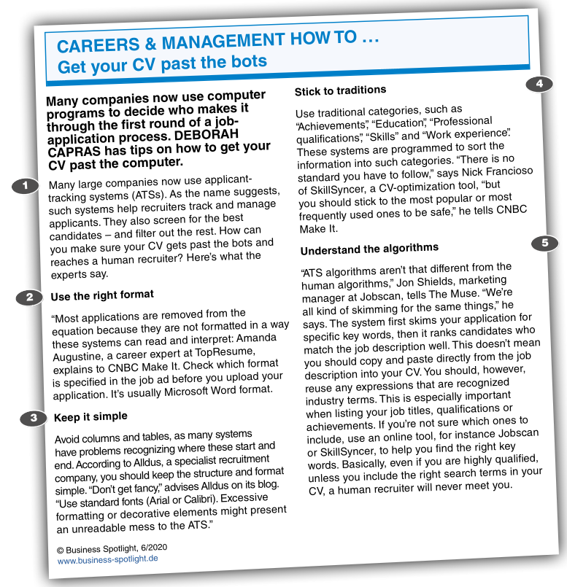

3. Understanding the article

Decide whether the statements are true (T) or false (F) according to the article.
Correct any that are false.

1. You should use different fonts and put images in your CV to make it stand out.
______________________________________________________________________________
______________________________________________________________________________

2. Many large companies now use human recruiters to skim applications before they get passed onto bots.
______________________________________________________________________________
______________________________________________________________________________
3. Include categories and headings that the ATS expects to find.
______________________________________________________________________________
______________________________________________________________________________

4. Copy and paste words from the job ad into your CV to make it more industry specific.
______________________________________________________________________________
______________________________________________________________________________

5. Check the job ad to see if you should use a specific font in your application.
______________________________________________________________________________
______________________________________________________________________________

4. Vocabulary
a. Complete the table with words from the article.
person | noun | verb
_______________________ | _______________________ | apply
_______________________ | recruitment | recruit
_______________________ | _______________________ | advertise

b. Complete these questions with the best words from task a.

1. When did you last _______________________ for a job?
2. Where did you see the job _______________________ ?
3. How did you send your _______________________ ?
4. Did you talk to a human _______________________ ?

5. Video “Graduate assessment centres”

1.Look at the following sentences. How would you translate the two underlined words?
So your CV managed to get you a telephone interview and you didn’t muck it up, so you’ve been invited back to the all important assessment centre. Now this really is the final hurdle guys, so I asked my CareerPlayer friends for some advice.
muck up = _______________________
hurdle = _______________________

2.Who do the following people work for / what are their jobs?
 | job / department | company
James Meachin | ____________________________ | Pearn Kandola
Janet Cowell |  | _______________________
Michael Weary | ____________________________ | UBS Investment Bank
Matt Sevenoaks | Forensic department | _______________________
3. How long does a candidate stay at an assessment centre?
____________________________________________________________________________

4. What might a candidate be asked to do?
• ______________________________________________
• ______________________________________________
• ______________________________________________

5. What does the final example of an activity/exercise involve?
____________________________________________________________________________

6. What might the exercise be?
It might be a _______________________ where you are having a _______________________ about a _______________________.
It might be a _______________________ we are presenting to other people.
It might be a _______________________ where you are asked to give your _______________________ on a particular type of business problem.
7. Why are these given?
____________________________________________________________________________

8. What sort of performers must they be?
____________________________________________________________________________

9. What do a lot of companies say about graduate recruiting?
____________________________________________________________________________

10. In a competency based interview, what are all the questions going to be around?
• ____________________________________________________________________________
• ____________________________________________________________________________

11. Gap Fill:
To succeed at a competency based interview you need to know what kinds of things _______________________ are looking for. That’s quite easy to find out. Generally there are a similar set of _______________________. Once you’ve really _______________________ what those things are, you can then look at what your experiences are and try and _______________________ those to those specific areas employers are interested in.Probably the biggest way _______________________ can stand out in my experience is actually having something _______________________ to talk about that’s very work _______________________. An awful lot of graduate _______________________ hear very similar examples of experience from candidates especially where candidates talk about their _______________________ and their exams.Answer the question that you’ve actually been asked and I think that is a really big mistake that many people make is that you go off at a _______________________.

12. What is an e-tray exercise?
• ____________________________________________________________________________
• ____________________________________________________________________________

13. What may happen at the end of the e-tray exercise?
____________________________________________________________________________

14. And why is this done?
____________________________________________________________________________

15. What advice is given about giving presentations?
• ____________________________________________________________________________
• ____________________________________________________________________________
• ____________________________________________________________________________

16. According to the report there are two important aspects to a presentation:
• ____________________________________________________________________________
• ____________________________________________________________________________

17. What should you not be during your presentation?
____________________________________________________________________________

18. Look at the script for this part of the report. How would you translate the underlined word?
Lastly, group exercises. Is it all about team-bonding and being the keenest person in the room?
keenest = ____________________________________________________________________

19. What is one myth about group exercises?
____________________________________________________________________________

20. What really matters to an organisation?
• ____________________________________________________________________________
• ____________________________________________________________________________

21. What expression (phrasal verb) used in the report means when someone does not listen to what someone else is saying and carries on speaking without paying attention.
____________________________________________________________________________

22. According to the report, what do assessment centres create and what is their aim in so doing?
Create: ______________________________________________________________________
Reasons: 1. ________________________________________________________________
2. ________________________________________________________________

23. What expression is used to improvise, to do something without preparation?
____________________________________________________________________________

24. What is a big mistake that candidates often make?
____________________________________________________________________________

Class 4 - The written CV

1. Warm-up

Decide which of these you would include in a CV and which you would not.
Give reasons for your answers.
- your photo
- your home address
- your hobbies
- any work experience you have had
- the name of the school/university you went to
- your gender
- your marital status
- your biggest achievement
- a list of languages you speak
- your date of birth

2. Advice for CVs

Explain what the speakers in a–e mean by matching the statements with their follow-ups 1–5.

a) “I use online CV templates.” _____________
b) “I like to use bullet points in my CV.” _______________
c) “When I write about my work experience, I put the information in chronological order.” __________
d) “I only write about relevant experience and education.” _____________
e) “I put my CV objective at the top of the CV and it is usually very short.” _____________

1) “I write a couple of sentences about myself and my career goals.”
2) “For instance, I once did a painting course but I won’t write about it if I decide to try and get a job in accounting.”
3) “They have nice designs and when I use them I don’t have to think about details like where to put my email address.”
4) “This way, the most recent job is at the top and the first job is at the bottom.”
5) “I can use them to clearly list what my jobs involved.”
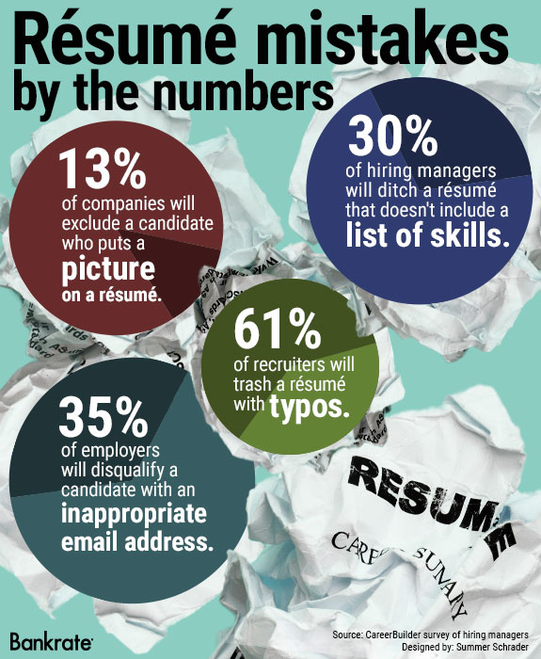

3. Mistakes on CVs

What do you think are the
main sources of CV rejection?
Explain the figures in the infographic.
Give examples and predict
how an employer could react.

 | Examples of mistake | Employer’s predictable reaction
picture | __________________________ | __________________________
list of skills | __________________________ | __________________________
typos | __________________________ | __________________________
email address | __________________________ | __________________________

Then, brainstorm three more mistakes frequently made by candidates and how employers might feel about them.
1. _____________________________________________________________________________
2. _____________________________________________________________________________
3. _____________________________________________________________________________

4. Video “Résumé basics”

Watch the first part of a video (00:00 to 01:23) about writing a résumé (another word for CV) and match the types of résumés with the statements.

This type of résumé is good for people who have had a long break from work.
_______________________________________
Your skills are as important as your work experience in this résumé.
_______________________________________
In this résumé the earliest experience is written at the bottom.
_______________________________________

Watch the second part of the video (from 01:24–02:58) and decide if the statements are true or false according to the speaker. Correct the false statements.

a) You have to include your phone number in the contact information section.
____________________________________________________________________________
b) The résumé objective should say something about your skills.
____________________________________________________________________________
c) You should write at least two bullet points under each job title.
____________________________________________________________________________
d) You should only list soft skills.
____________________________________________________________________________
e) You don’t have to write where your school/university is.
____________________________________________________________________________

5. An example of CV

Look at the CV below and discuss the questions.

• Is it a chronological, functional or combination CV? ____________________________________

• Which pieces of advice did the writer use?
- You have to include your phone number in the contact information section.
- The résumé objective should say something about your skills.
- You should write between three and five bullet points under each job title.
- You should include both hard and soft skills.
- You should write where your school/university is.
____________________________________________________________________________

• Which of the skills in the CV are soft and which are hard? Why do you think so?
____________________________________________________________________________
____________________________________________________________________________
____________________________________________________________________________

• Would you add any of those skills to your CV? Why / Why not?
____________________________________________________________________________

• What do you like or dislike about the CV?
____________________________________________________________________________
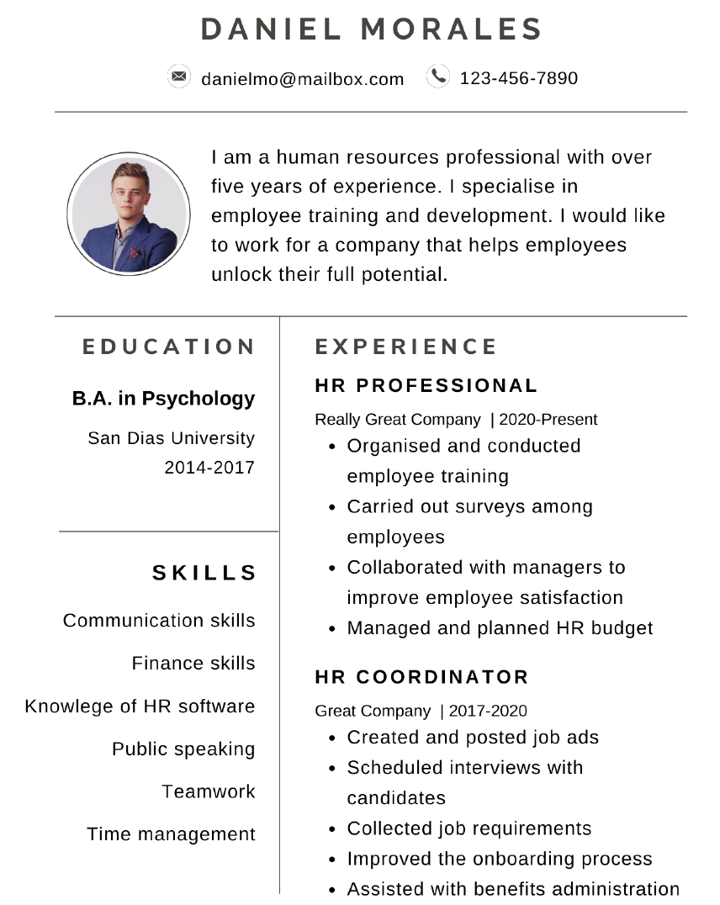

Look at the CV objective again and complete the notes.

a) name of Daniel’s profession: ____________________________________________________
b) how much experience Daniel has in the profession: __________________________________
c) the important skill Daniel includes: ________________________________________________
d) Daniel’s career goal: ___________________________________________________________

6. Objective or Career Aim

Your CV should include an aim / objective. This is an excellent way to grasp attention and to give the reader some focus to the sort of career you want to enter.

• avoid overgeneralized statements, such as “A position allowing me to utilise my knowledge and expertise in different areas.”
• avoid statements that focus only on what a company can do for you: “A position where I gain experience in working on IT problems.”
Prefer: “To find employment as a junior scientist or technician to launch my scientific career.”
or “To develop my skills/acquire hands-on experience in the field of……through an internship.”

→ Write your Aim / Objective
____________________________________________________________________________
____________________________________________________________________________
____________________________________________________________________________
____________________________________________________________________________
____________________________________________________________________________
____________________________________________________________________________

Chronological CV - Find the equivalents for these words
à la recherche de: ___________________________
un poste d'ingénieur: ___________________________
un stage: ___________________________
compétences mises au service de...: ___________________________
Licence en sciences : ___________________________
obtenir son diplôme avec les félicitations du jury: ___________________________
résoudre (des problèmes): ___________________________
effectuer (une tâche): ___________________________
recueillir (des données): ___________________________
mettre en place: ___________________________
faire office de: ___________________________

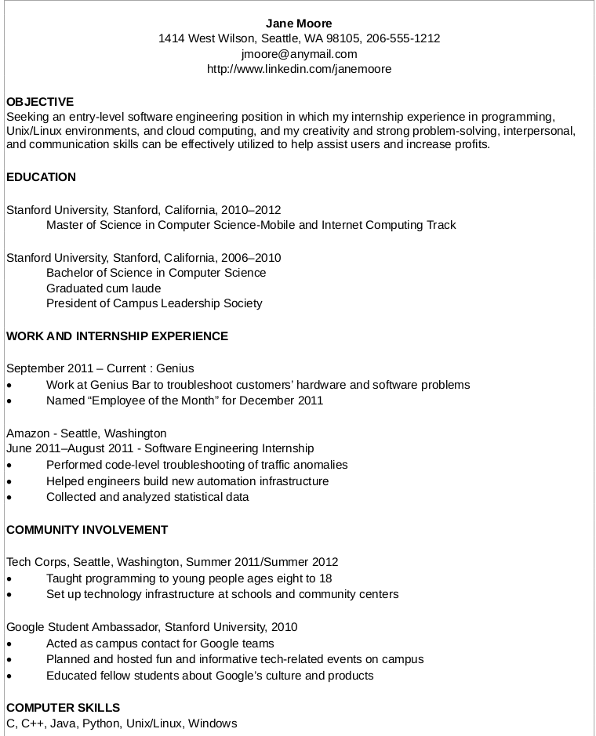

Functional or skill-based CV - Find the equivalents for these words
poste à temps plein : ___________________________
à dominante … : ___________________________
moyenne des notes obtenues [acronyme] : ___________________________
interface de programmation [acronyme]: ___________________________
étudier, concevoir et mettre en œuvre: ___________________________
récolter des données sur (un projet) : ___________________________
mettre à niveau : ___________________________
concours : ___________________________

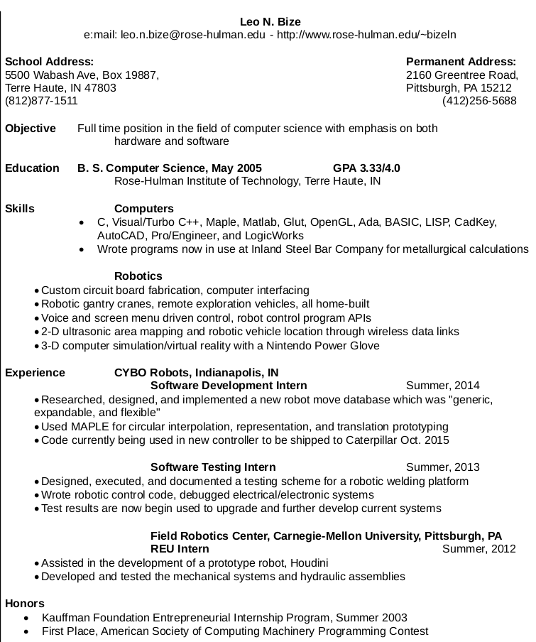

Combination CV - Find the equivalents for these words
diplôme de … : _________________________ enquêtes : ___________________________
actuellement : __________________________ acquérir de l'expérience à travers … : ______
obtention du diplôme : ___________________ former les nouveaux employés : ___________
circuit imprimé ARM : ____________________ sites institutionnels : ____________________
excellente connaissance de ...: _____________ fournir un accompagnement de niveau II : ___
en langage courant : _____________________ tenir à jour un inventaire : ________________
mener des recherches : __________________ assurer un service client efficace et courtois: _
notes de synthèse : _____________________ engagement, enthousiasme : _____________
groupes de discussion : __________________
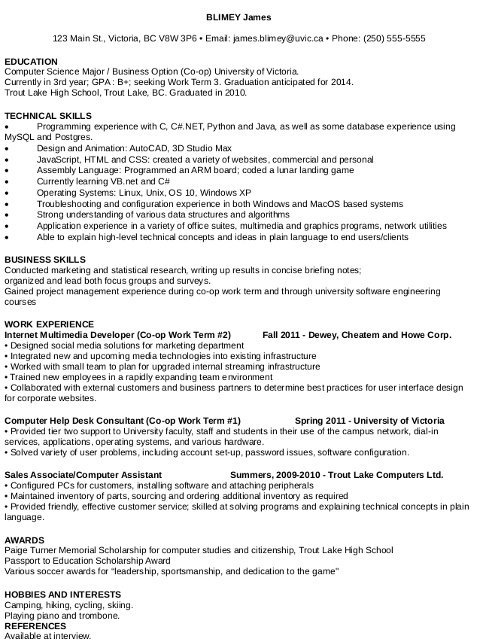


Degree equivalents
You do not have a “Bachelor’s degree”, you have a French “Licence”, equivalent to a Bachelor’s degree. Here are the equivalents.

Age or  number of years | France | Great Britain | The United States
16 | Diplôme National du Brevet (DNB) | GCSE  (General Certificate of Secondary Education) | No equivalent
18 | Baccalauréat  Mention TB  Autre mention | A-Levels (mention main subjects)  With higher honours  With distinction | High School diploma  With highest honors  With distinction
 | DEUG (before 2004, no longer delivered) | French two-year university degree | Junior College Degree
After 3 years of university studies or 4 years in some British universities and in the USA | Licence  Mention AB  Mention B  Mention TB | Bsc (Bachelor’s degree of science) in + specialist subject  or BA (Bachelor of Arts)  2.2 (two-two)  2.1 (two-one)  first | Bsc (Bachelor’s degree of science) in + specialist subject  or BA (Bachelor of Arts)  Cum laude  Magna cum Laude  Summa Cum Laude
After 4 years of university studies or 5 in some British universities |  | Master’s degree  Msc (Master of science) | “graduate school”
5 years of university studies | Master | Master’s degree | Master’s degree
After a minimum of 8 years of university studies | Doctorat | Ph.D + in specialist subject  or Doctorate in + specialist subject | Ph.D + in specialist subject  or Doctorate in + specialist subject

Other useful equivalents
MIAGE | Computer methods applied to Business Management
Formation en alternance | Sandwich course, work-study course, course with in-company periods
D.U.T. / B.U.T.. | Technical degree or HND (Higher National Diploma)
IUT | University Institute of Technology / Polytechnic school
Ecole d’ingénieur | Engineering school
B.T.S. | Degree of Qualified Technician or HNC (Higher National Certificate)
Classes Préparatoires aux Grandes Ecoles (CPGE) | Preparation for the competitive entrance examination to French Advanced Engineering Schools
Diplôme de secouriste / secouriste du travail | First Aid Certificate / Occupational First Aid Certificate
GSON | Data Science Skills Certification (complementary to Master’s degree)

How to assess your level in foreign languages

1. Make sure you know what these words mean and practise pronunciation
fluent in ___________________________
proficient in ___________________________
bilingual ___________________________
multilingual ___________________________
native speaker ___________________________
intermediate ___________________________
advanced ___________________________

2. Discuss the following issues
What are the various language skills commonly included in CVs?
____________________________________________________________________________

What is the importance of each language skill in various professional contexts?
____________________________________________________________________________

Analyse the language skills sections of the above 3 CVs and identify the language skills mentioned.
____________________________________________________________________________

Discuss the descriptions in these CVs: effective or not? Make a note of useful vocabulary and idioms.
____________________________________________________________________________

Do’s and Don’ts for CV writing

Don’t
- Write about yourself in the third person, for ex. He has worked to a consistent level...
- Attempt to be humorous.
- Leave gaps.
- Split an important point between two pages
- Overdo your hobbies.
- Use colourful paper or designs, fancy fonts, colours etc.

Do
- Read the details of the post carefully and tailor your CV to meet the requirements of the job
- Be brief and to the point : keeping your sentences short makes your CV sound punchy and concise.
- Focus on your strengths : stress the skills you have which are particularly relevant for the post ; if you have no employment experience, focus on your education
- Place temporary jobs not relevant to the position together, e g: 2012-2014: Various temporary jobs
- Include hobbies relevant to the job, such as those demonstrating teamwork and commitment
- Space = importance. Give more space to those parts of your CV that sell you better.
- Check spelling, punctuation (capitals !), grammar

Class 5 - The cover letter

1. Layout
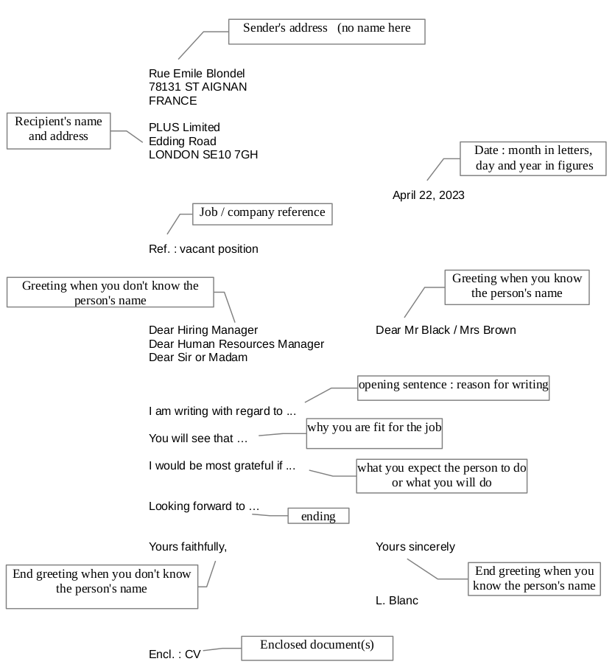

2. General guidelines

A cover letter should be short: one page maximum, no more than 4 paragraphs .
It must be typed and conform to the standards of English business correspondence .
Use spell-check (first select English as the language for the document) .
Mister, Mr, Ms and Miss must be followed by a last name (family name).
DO NOT translate your French letter .
DO NOT use contractions or slang (I'd, can't, guys, gonna, etc)
DO NOT include the city when you write the date.

3. Structure
The use of the AIDA pattern (ATTENTION, INTEREST, DESIRE, ACTION) will result in a cover letter that is both pleasing to read and effective.
The first paragraph (A I )
Two or three sentences in length.
Start with an interest-creating sentence in which you appeal to the employer’s needs.
Be as specific as you can about the position desired.
Give information to show your specific interest in the company.

The second paragraph ( D )
Usually three to five sentences in length.
- Create desire. Give details of your background that will show the reader why he should consider you as a candidate.
- Emphasize a match between the skills which you possess and those required by the employer. Always say what you can do for the organisation, how you can contribute.
- Tell your story but keep it brief and to the point.
- At the end of this paragraph make a reference to your CV/resume.
The third paragraph (A )
Two to three sentences in length.
In your closing paragraph you ask for action. Tell the employer how to get in touch with you, and thank the person for taking time to give you consideration.

4. Useful language

Qualifiers

Do not hesitate to be specific when relating to your experience or knowledge. To do so, use a qualifier.

Match adjectives and what they can describe.
Use... |  | To describe...
hands-on, strong, solid, excellent, wide, extensive, broad, varied, successful |  | personality
in-depth, detailed, thorough, first-hand, extensive |  | experience
outstanding, excellent, proven, strong |  | a position
leading, pioneer, small-sized, medium-sized, top-ranking, large, major, fast-growing, reputation of excellence |  | ability / background / skill
challenging, rewarding, responsible, entry-level, |  | respecting deadlines
leading-edge, cutting-edge, latest, most advanced |  | a technology
innovative, highly organized, strongly / highly motivated, deeply committed, outgoing, enthusiastic, keen to join a team |  | knowledge
can meet deadlines, can deliver on time, good time management |  | a company

Exercises:

a- Greetings

When you are writing to a woman but you don't know her name, use: ________________________
When you are writing to a man but you don't know his name, use: ___________________________
When you know the job title of the person but not their gender or name, use: ___________________________ or ___________________________
When you don't know exactly who will read your letter, use: ___________________________
If you begin with: Dear Ms / Mrs / Mr James, use the closing salutation: _______________________
If you begin with: Dear Sir or Madam, use the closing salutation: ___________________________
b- Translate these sentences from a cover letter:

The first paragraph

Je souhaite postuler pour le poste de stagiaire publié dans…. J’obtiendrai mon Master en juin.
____________________________________________________________________________
____________________________________________________________________________
Je suis très intéressé par le poste de….
____________________________________________________________________________
Professeur Watson m’a recommandé XL Computer pour un poste de stagiaire.
____________________________________________________________________________

The second paragraph

Un stage chez [company] sera la meilleure occasion d’élargir mes connaissances dans le domaine de …
____________________________________________________________________________
____________________________________________________________________________
….d’acquérir savoir-faire et expérience pratique
____________________________________________________________________________
…et de me familiariser avec les pratiques professionnelles à l’étranger.
____________________________________________________________________________
Veuillez trouver ci-joint mon CV qui vous procurera une vue plus complète de ma formation/de mes compétences/aptitudes.
____________________________________________________________________________
____________________________________________________________________________
The third paragraph

Si vous désirez de plus amples renseignements, vous pouvez me contacter au…..
____________________________________________________________________________
Je suis disponible pour un entretien à votre convenance.
____________________________________________________________________________
Dans l’attente de votre réponse…
____________________________________________________________________________
Je suis convaincu que ma formation universitaire et mon expérience seront utiles à votre entreprise.
____________________________________________________________________________
____________________________________________________________________________

c- Choose the best word(s) to complete each blank.

1. I'm writing ____________________ your advertisement in the Los Angeles Times.
in response to to respond at in respond to

2. I'm writing to ____________________ the possibility of employment with your company.
question about inquest about inquire about

3. I have a ____________________ deal of experience in web development.
lot large great

4. I'm a ____________________ motivated self-starter.
high highly heightly

5. I have been ____________________ for my ability to manage others.
noticed notified recognized

6. I would very much like to meet with you __________________ to discuss this position.
in person personal for a chat

7. I would very much like to meet with you to discuss this position _________________.
in detail in details in detailed

8. I will call you on Tuesday to arrange a ____________________ meeting.
eye-to-eye nose-to-nose face-to-face

9. My main area of ____________________ is ...
expert expertise experience

10. As the ____________________ CV/resume illustrates, ...
attached enclosed encapsulated
d- Fill in the blanks in the cover letter below
You will need to use the English equivalents of these French expressions
chef du personnel : ____________________
eu connaissance de : ____________________
offre d’emploi (poste vacant) d'ingénieur informatique : ___________________________________
dès l'obtention de mon diplôme : ________________________________________
correspondent à vos attentes : ________________________________________
j’'ai la responsabilité de ... : ________________________________________
une solide formation en … : ________________________________________
ces compétences seraient utiles à … : ________________________________________
explique plus en détail : ________________________________________
répondre à vos exigences: ________________________________________
si vous souhaitez de plus amples renseignements: _______________________________________
dans l'attente de votre réponse: ______________________________________________________

Cover Letter Sample
Charles S. Maines,
1127 Irving Road,
Columbus, OH 43215,
(740)-460 9366.
Date: May 1, 2024.
Mr. Ira A. Blea, ________________________________________,
National Solutions,
2197 Lighthouse Drive,
Springfield, MO 65804.

Dear Mr. Blea,
I _____________________________________ a ________________________________________ at National Solutions from an online research through Career Services at Virginia Tech, where I am completing my Master's degree in Computer Engineering. I believe that my qualifications ________________________________________ and would like to apply for the position ________________________________________ in May this year.
As a graduate student, I am one of the six members on a software development team writing a computer-aided aircraft design program for National Space Center. _______________________________________ designing, coding, and testing of a graphical portion of the program for graphics input and output. I have ______________________________________ computer-aided design, software development, and engineering, and believe that ________________________________________ the designing and manufacturing aspects of Template software. Enclosed is my resume that _______________________________________ my qualifications.
I am confident that my skills will ________________________________________, and I would appreciate the opportunity of an interview with you. _______________________________________, feel free to call me at your convenience.
Thank you for your time and consideration. _____________________________________________.
Sincerely,
Charles S. Maines,
Senior Student,
ISTech., Columbus
Enclosures:
1. Resume - myresume.doc

Class 6 - Body language

1. Warm-up

Nonverbal communication makes up about two-thirds of all communication between two people or between one speaker and a group of listeners. So body language is important.
How much do you know? Match the gestures with the illustrations.

Torso
c
1.torso forward
a
b
2. torso backwards
3. torso upright

Hands and arms
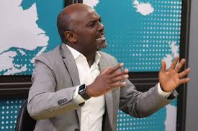a
c
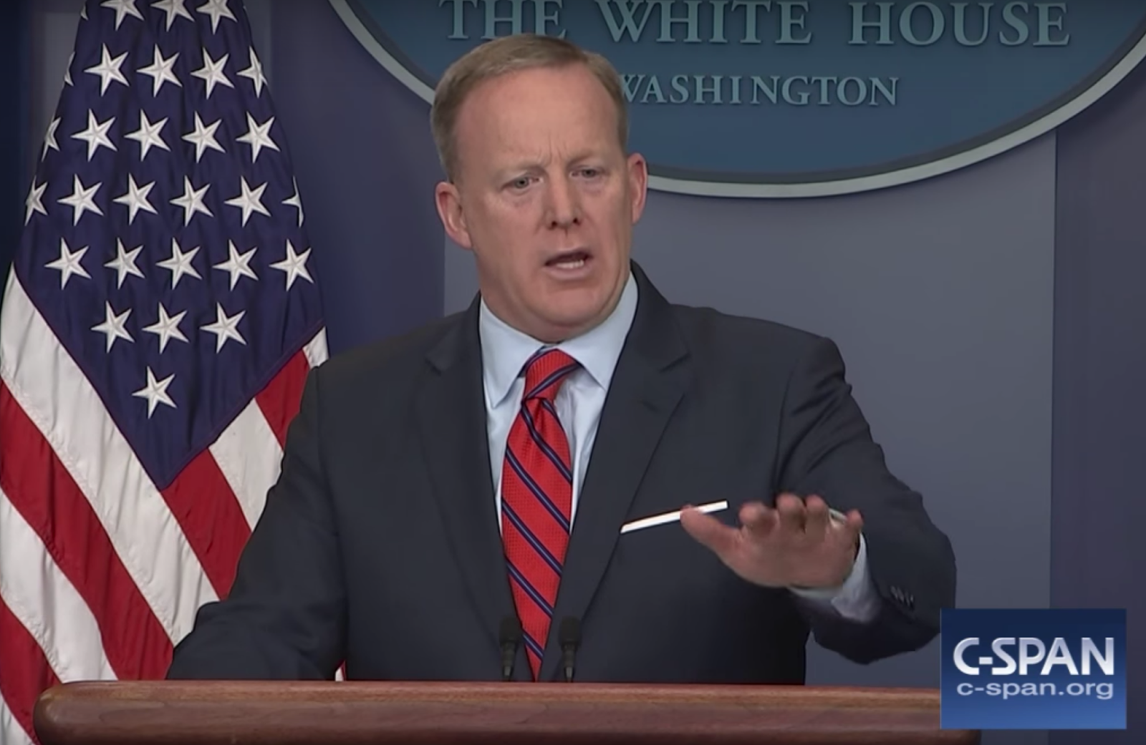b
1. Hiding hands
2. Palms held out, upwards
3. Palms down
4. Arms apart, palms parallel, cutting
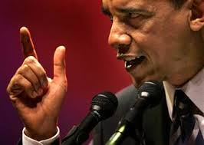d
f
g
e
5. Palms moving up and down
6. Palms downwards sideways
7. Pointing (with finger)

Eyes
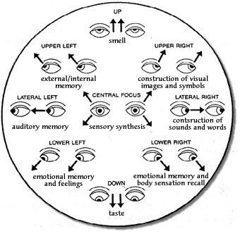
1. looking right
2. looking left
3. direct eye contact (when speaking)

2. Video “Your body language may shape who you are”

Match the words from the video with their equivalent.

words from video | equivalent | words from video | equivalent
a hack | ____________________ | an outcome | ____________________
to give away | ____________________ | a physician (US) | ____________________
to hunch | ____________________ | to sue | ____________________
to tweak (informal) | ____________________ | dramatic | ____________________
awkward | ____________________ | gubernatorial | ____________________
contemptuous | ____________________ | pride | ____________________
a wink | ____________________ | sight | ____________________
an inference | ____________________ | to wrap up | ____________________

Watch the Ted video and answer the questions.

1. What does Amy Cuddy want her audience to do?
____________________________________________________________________________

2. What is interesting to observe in others' body language?
____________________________________________________________________________

3. Which term is used by scientists for 'body language’?
____________________________________________________________________________

4. What can be predicted simply by watching someone's body language?
____________________________________________________________________________
____________________________________________________________________________

5. Explain the anecdote with the doctor.
____________________________________________________________________________
____________________________________________________________________________

6. What about political candidates?
____________________________________________________________________________
____________________________________________________________________________

7. Who else is influenced by non-verbals?
____________________________________________________________________________
8. What's her job? What does she study? Where does she work?
____________________________________________________________________________

9. What is she especially interested in?
____________________________________________________________________________

10. How do animals and humans express power?
____________________________________________________________________________

11. How do people express their pride of winning at a physical competition?
____________________________________________________________________________

12. What unexpected category of people does the same thing?
____________________________________________________________________________

13. What happens when we feel powerless?
____________________________________________________________________________

14. What happens when we are facing someone powerful?
____________________________________________________________________________

3. Video “Body language in a job interview”

Complete the 10 tips

1 Greet modestly with an equal handshake
It’s always difficult greeting someone for the first time. Humm, a little aggressive. Your interviewer knows you want the job so don’t ____________________ them with an ____________________ gesture. Avoid noise flicking, high fives, air kisses or jazz hands. Play it simple and ____________________ to avoid dominant vibes.

2 Relax into your chair
The interviewer will show you to your chair. This is the all important hot seat and the way you sit conveys a lot of information. Take a moment to position and ____________________...but not too comfortable. Look relaxed. It encourages your interviewer to feel at ease in your company. However, no matter how informal the discussion, avoid ____________________. You’re not at home watching the telly now.

3 Don’t form body barriers
An interview is not the time to come over all shy and retiring. ____________________ across your chest or ____________________ conveys a nervous, negative or even aggressive attitude. That’s it! Use your upper torso to define an open and honest attitude. Keep the back straight and ____________________ to demonstrate interest.

4 Keep your hands away from your face
Children cover their mouths when they’re telling lies. As we get older, this subconscious habit turns into ____________________, ____________________ or the tweaking of the tool shed. If you’re stroking the nose, caressing sideburns or chin scratching, these actions can make your interviewer feel ____________________. Right! Avoid ____________________ by keeping your hands ____________________ or relaxed in your lap.

5 Stay focused
It’s important to concentrate during your interview. Stop ____________________ or repetitive looks to the floor or ceiling. By moving the eyes around the room, you risk looking ____________________, ____________________, or just plain ____________________. Give your interviewer your full attention. Look and listen.

6 Sit still
During the interview, don’t transfer your butterflies into ____________________, like ____________________. Watching your legs perform a neat rendition of Riverdance under the table is one distraction the interviewer doesn’t need. Channel your nerves into ____________________, yet ____________________ hand gestures to endorse what you say.

7 Stop being picky
Yes, that’s a nice tie but ____________________ or grooming of your garments conveys an element of ____________________ or ____________________. Even if you’re certain there’s a speck on your clothes, leave it alone. No one else will notice but you.

8 Maintain eye contact
Keep your eye contact ____________________ and ____________________… but remember to blink. An interview can be intense so avoid adopting a serial killer stare. Instead _________________
____________________ on your interviewer’s face and look within that zone. Try not to __________
____________________ below the triangle though. Any further south and things start to get a little intimate.

9 Steer your body
Crossing your legs during the interview is agreeable and will not appear as ____________________ as crossing your arms. It’s useful if you ____________________ the interviewer with your knees or your feet. This will help you position your body so you’re ____________________ on them alone. But don’t overdo it.

10 Use your hands
Being physically expressive as you speak shows ____________________ in what you’re saying. Use your hands to ____________________answers or ____________________ to your ideas. That’s it! The interviewers think that you know what you’re talking about. However, don’t exaggerate the gestures. You’re not breaking moves at the local discotheque. And avoid _____________________. Instead, motion with your hands ____________________ as this signifies an offering gesture.

4. Body language preparation for the video profile
Here are some basic principles that you need to keep in mind:

1. Body language in general
- Hands and arms gestures must start from you towards the audience (shows willingness to share and open mindedness), below your face, above the desk.
- Eye contact is of course essential and must be expressive.
- Any object you place between you and the audience may indicate you place an “obstacle” or protect yourself.

2. Voice
- Make it expressive and interesting by varying intonation and pace.
- When stressed out, people have a tendency to speak too fast. Be aware of your own pace and, if necessary, slow it down (by 20%).
- Lower your voice. This will give more meaning to what you are saying.
- Pause before and after important words or phrases.
- Make sure your voice does not go up at the end of sentences. This would create doubt in what you are saying.
- Articulate
- Speak up. Avoid mumbling. Be confident. What you are saying is interesting.
- Make sure you pronounce the names of degrees, places, schools correctly.

Class 7 - Skills (1)

1. Warm-up

Can you give some examples of skills (e.g. camping skills: building a campfire, putting up a tent)?

English skills: _____________________________________________________________________
________________________________________________________________________________
Computer skills: ___________________________________________________________________
________________________________________________________________________________
Life skills: ________________________________________________________________________
________________________________________________________________________________
Communication skills: ______________________________________________________________
________________________________________________________________________________
Reading skills: ____________________________________________________________________
________________________________________________________________________________
• Which skills do you have?
________________________________________________________________________________
• Which skills did you develop when you were a child? Did anyone teach you these skills?
________________________________________________________________________________
• Which skills would you use at work? Give some details.
________________________________________________________________________________
________________________________________________________________________________
• Which skills would you like to work on? Why?
________________________________________________________________________________
________________________________________________________________________________
• How could someone improve their:
- presentation skills? ___________________________________________________________
________________________________________________________________________________
- communication skills? ________________________________________________________
________________________________________________________________________________
- computer skills? _____________________________________________________________
________________________________________________________________________________

Look at the pictures. What is the difference between hard and soft skills?

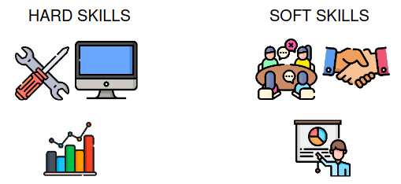
________________________________________________________________________________
________________________________________________________________________________

2. Video

Watch a video about hard and soft skills and check your ideas.

Decide which sentences are about soft skills and which are about hard skills. Then, watch the video again and check your answers.

a) You can’t do your work without them. ❑ soft skills ❑ hard skills video: ………...
b) They are also called ”people skills”. ❑ soft skills ❑ hard skills video: ………...
c) Communication is an example of this type of skill. ❑ soft skills ❑ hard skills video: ………...
d) You can learn them in school or when you work. ❑ soft skills ❑ hard skills video: ………...
e) You need to practise them with other people. ❑ soft skills ❑ hard skills video: ………...
f) You can measure them easily. ❑ soft skills ❑ hard skills video: ………...
g) You need them if you want to be successful in your job. ❑ soft skills ❑ hard skills video: ………..

Match the halves to create different skills.
a) being a
b) being a team
c) project
d) driving a
e) being
f) time
g) public
1) player
2) creative
3) good leader
4) management
5) management
6) speaking
7) car

Look at the skills in the previous exercise and discuss the questions.

• Which of the skills are hard and which are soft? If you think that some skills can be both hard and soft, explain why.
________________________________________________________________________________
________________________________________________________________________________
________________________________________________________________________________

• Why are soft skills important in a workplace?
________________________________________________________________________________
________________________________________________________________________________________________________________________________________________________________

• Should soft skills be a school subject? Why / Why not?
________________________________________________________________________________
________________________________________________________________________________________________________________________________________________________________

• Is it easier for you to develop soft or hard skills? Can you give examples?
________________________________________________________________________________
________________________________________________________________________________
________________________________________________________________________________

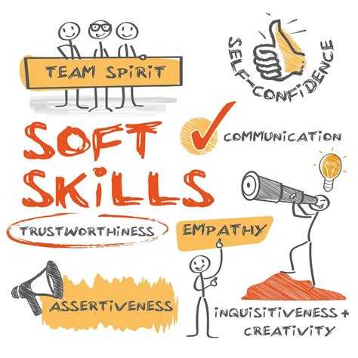
Vocabulary exercise

noun | adjective (“I am …”) | meaning (“I can …”)
self-confidence | __________________ | ___________________________________________  ___________________________________________
trustworthiness | __________________ | ___________________________________________  ___________________________________________
empathy | __________________ | ___________________________________________  ___________________________________________
assertiveness | __________________ | ___________________________________________  ___________________________________________
inquisitiveness | __________________ | ___________________________________________  ___________________________________________

3. Employability

What does employability mean to you?
________________________________________________________________________________

Watch a video to see what experts think employability means and discuss the questions.

Are their thoughts similar to yours?
________________________________________________________________________________
To what extent do you agree with their views?
________________________________________________________________________________
How can we develop employability skills while still at school / university? ________________________________________________________________________________
________________________________________________________________________________

4. Prove your skills
Recruiters look for hard evidence that candidates have the skills their vacancy requires.
An instructive exercise is to list your skills together with examples of when you applied them.

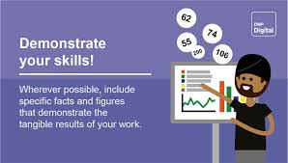

Typical skills are:
problem-solving written communication verbal communication adaptability
computer project management organisation teamwork
interpersonal decision making conflict resolution public speaking
leadership planning & organizing role modeling dedication

And typical qualities include:
practical evaluative meticulous creative
logical open to new experiences analytical adaptable

What skills and qualities from above do you think you have?
Choose one, and find instances in your personal experience, or your training to prove it. (use the list of action verbs)

Here is a list of action verbs to describe skills and accomplishments under the professional experience heading. You should use them to describe any skills or accomplishments you may want to highlight.

achieved
constructed
expanded
led
sampled
adapted
consulted
experimented
maintained
scheduled
administered
contacted
explored
managed
selected
advertised
contributed
expressed
marketed
serviced
advised
controlled
facilitated
managed
set up
aided
co-operated
explored
modelled
simplified
analysed
co-ordinated
focused
modified
sold
applied
created
forecasted
negotiated
solved
approved
debugged
found
operated
sought
assembled
decided
graded
outlined
specialised
assessed
defined
guided
overhauled
spoke
assisted
delegated
handled
participated (in)
streamlined
authorised
delivered
harmonised
performed
structured
bought
demonstrated
headed
pinpointed
summarised
budgeted
described
hired
planned
supervised
built
designed
developed
hosted
prepared/ studied
calculated
diagnosed
identified
presented
supplied
classified
directed
implemented
produced
supported
collaborated
displayed
improved
promoted
surveyed
collected
distributed
increased
purchased
taught
combines
drafted
informed
reduced
tested
communicated
drew
initiated
reorganised
trained
compared
edited
inspected
researched
translated
compiled
ensured
installed
resolved
treated
computed
established
integrated
restored
troubleshot
concentrated
evaluated
investigated
revamped
updated
conducted
examined
launched
reviewed
wrote

Class 8 - Skills (2)

1. Warm-up

Match the words from box A with the words from box B to make common phrases. Then, match them with their meanings.

BOX A | BOX B
draw  commit oneself  extracurricular  experience something  grasp  take | action  activities  an opportunity  conclusions  first-hand  to the task

Meanings:
decide what to believe about something after you have considered the facts:
________________________________________________________________________________
dedicate or devote oneself to something: ________________________________________________________________________________
take advantage of something when it happens: ________________________________________________________________________________
experience in a direct way by doing something yourself: ________________________________________________________________________________
things that you do at school or college that are not part of your course: ________________________________________________________________________________
do something to achieve an aim or deal with a problem: ________________________________________________________________________________

2. Video “Tony Walker, deputy MD at Toyota”

Discuss the questions in pairs

What skills will you gain from your degree?
________________________________________________________________________________

What advice would you give to students in your course about their future employment?
________________________________________________________________________________

What are the most important skills people look for in an employee?
________________________________________________________________________________

What is your career plan once you finish university?
________________________________________________________________________________

Watch a video and note down how the speaker answers the four questions above.

What skills did you gain from your degree?
________________________________________________________________________________

What advice would you give to students about their future employment?
________________________________________________________________________________

What are the most important skills people look for in an employee?
________________________________________________________________________________

What was your career plan once you finished university?
________________________________________________________________________________

3. Motivation

Discuss whether you agree with the statement.
“Don’t work for the money, work to do a good job!”

Complete the quotes with the words motivate, motivating, motivated or motivation.

“If you must have __________________, think of your paycheck on Friday.”
Noel Coward, English playwright

“I tend to be... they say ‘workaholic,’ which I just find to be ‘__________________.’”
Sarah Hay, American actress and ballerina

“People want to be part of something that's bigger than themselves. It's __________________. It helps all of us to work harder.”
Paul Jacobs, American businessman

“The best way to __________________ me is to tell me I can't do something.”
Jimmy Graham, American football player
Discuss the quotes and say if you agree or disagree with them.

Read the sentences and complete the tasks below

a) It’s motivating to have an interesting and creative job.
b) If people are happy with their salaries, they are more motivated to do a good job.
c) I’m very motivated when I work in a team of people I like.
d) I think it’s important that you can develop in your company and that it provides a lot of promotion opportunities.
e) Offering employees cool perks such as a gym membership is a great idea to motivate them.

Tasks
1) Find two synonyms of ‘give’: __________________
2) Find a noun that means a move to a more important job or position in a company: __________________
3) Find a noun that means an additional payment or advantage that you get in
your job: __________________

Guess three synonyms of the word ‘perk’. The letters should help you.

a) b _ _ us
b) ex _ _ a
c) b _ _ _ _ i t

Video : “Cool perks”

You’re going to watch a video in which employees are talking about ‘cool perks’ their companies offer. Look at the list below and mark four which you think the employees will mention.
• private healthcare
• happy hours
• car wash service
• language classes
• travel discounts
• free food
• company car
• parental leave
• company kindergarten
• sports tournaments

Watch the video and check your answers
• private healthcare
• happy hours
• car wash service
• language classes
• travel discounts
• free food
• company car
• parental leave
• company kindergarten
• sports tournaments

Watch the video again and match the benefits to the companies: AOL, Adobe or Yahoo.
a) meditation room __________________
b) yoga classes __________________
c) fitness centre or classes __________________
d) massage __________________
e) lip sync battles __________________
Read the sentences and match the words and phrases in bold to the meanings below.

a) The company offers a lot of perks that are a magnet for millennials.
b) I’m jealous of his amazing life and all the things he can do.
c) They provide many sweet extras that their employees just love!
d) It’s one of the perk-packed companies that everyone wants to work at.
e) I think everyone will say yes to such a great offer.

Meanings:
1) having a lot of perks __________________
2) unhappy because someone has something that you would like __________________
3) awesome __________________
4) agree to something or think that something is great __________________
5) something or someone that attracts many people or things __________________

Discuss the questions

• What motivates you at work? Are you motivated by perks?
• Which of the benefits that were mentioned in the video would you say yes to?
• What sweet extras are a magnet for people looking for a job now?
• Are you jealous of any bonuses that your friends or family get from their employers?
• Which benefits are useless in your opinion?

Class 10 - The job interview (1)

1. Warm-up : Audio interview

Choose the best answer for each question below:

1. How long has Kate been working for KP Lewis?
a. 3 years b. 4 years c. 8 years

2. How long has she been working in the accounting department?
a. 3 months b. 4 months c. 8 months

3. Why is she leaving her job?
a. she is not well-paid b. her skills are under-used c. Her boss is horrible

4. Is travelling a problem for her?
a. yes b. no c. maybe

5. Why was she successful as a sales representative for a language school?
a. the school increased its profit b. it sold more books c. more people registered

6. What are her short-term goals for the future?
a. buy a house b. develop her skill set c. become a manager

7. What are her long-term goals?
a. move to a senior position b. start her own business c. work for a school

8. What is her greatest weakness?
a. perfectionism (working too hard) b. time management c. shyness

9. How well does she work under pressure?
a. she stresses a lot b. she is okay c. she does better under pressure

2. Reading

Look at the list. Do you think these are good or bad things to say in an interview?
Put ‘G’ (Good) or ‘B’ (Bad) next to each sentence.

1. I’m looking for new challenges. ________
2. I’m really nervous. ________
3. How much will I earn? ________
4. In the short-term I want to develop my sales skills and gain more experience in selling. ________
5. My weakness is that I work too hard. ________
6. I really need this job! ________
7. I work quite well under pressure. I find it very motivating. ________
8. My current boss is horrible. ________
9. No, I don’t have any questions for you. ________
10. I love the idea of free snacks on Fridays! ________

Complete the text below with statements from above.

Here are 7 things you should never say in a job interview:

1. If you don’t know your potential salary, you shouldn’t ask about it too early in the interview. If you do this, the interviewer will think you are only interested in money and nothing else. Employers want people who are a good match for the position that they are offering. Salary negotiations should wait till the end of the interview.

2. Companies do not want to hire someone who doesn’t have any confidence. So, it’s not always good to be honest. If you are nervous, you should try not to show it.

3. If the interviewer asks about your weaknesses, you should not reply with a standard response that sounds like a hidden strength. Experienced interviewers know this trick. Instead, tell the employer about a real weakness, but a weakness that isn’t so important for the job.

4. Don’t mention how much you like some of the company’s benefits, such as free snacks. The interviewer will think that you do not care about the success of the company.

5. Try not to show that you are desperate for the job. Desperation is a sign of weakness.

6. Never criticize a former boss or company. It’s not classy, and it will make you sound negative.

7. When the interviewer asks if you have any questions, don’t say "no." This makes you look unprepared for the interview or not interested in the job or company.

Discussion

Do you agree with the advice in the article?

3. How you really sound in job interviews

Watch the video, then complete the column “What they hear” and give advice.

Job interviews are all about making the right first impression. Put things the wrong way, and they may hear something you never intended to say.
 | What you say | What they hear
The first impression | Hi, I'm really excited to meet you. I saw on your daughter's blog that she has a gluten allergy, so I got these gluten-free cookies, I hope she likes them.
The first impression | Oh, I'm sorry, I didn't bring any copies of my résumé with me.
The first impression | Sorry I'm late due to traffic.
Advice
________________________________________________________________________________
________________________________________________________________________________

What happened with your previous job? | They really didn't know how to take advantage of my skills.
What happened with your previous job? | My old boss Tim, do you know him? I love Tim to death. He didn't really get social media, but god I love that guy.
Advice
________________________________________________________________________________
________________________________________________________________________________

What is your biggest flaw? | My biggest flaw is that I'm a perfectionist.
What is your biggest flaw? | Well, I'm not good at public speaking, or delegating, or working in Excel.
What is your biggest flaw? | I really don't have any flaws.
Advice
________________________________________________________________________________
________________________________________________________________________________
Where will you be in five years? | Where will I be in five years? In your job! Just kidding...
Where will you be in five years? | I wanna invent the next Uber.
Where will you be in five years? | I mean, honestly, I would just like really love to get away from the clients and this like business setting... Maybe I'll move to Europe or Africa or Asia, or open up an Etsy store... something like that.
Advice
________________________________________________________________________________
________________________________________________________________________________

4. Questions YOU ask at the end of the interview

What is the point of asking questions to the interviewer(s)?
________________________________________________________________________________
________________________________________________________________________________
________________________________________________________________________________
________________________________________________________________________________

There are 3 types of questions that you could ask. Guess what they are about.

Type 1: (tip: show you’re interested in working here!)
________________________________________________________________________________

Type 2: (tip: demonstrate interest about your future role)
________________________________________________________________________________

Type 3: (tip: dare to be bold!)
________________________________________________________________________________

Now brainstorm example questions for each category.

Type 1:
________________________________________________________________________________
________________________________________________________________________________
________________________________________________________________________________
________________________________________________________________________________

Type 2:
________________________________________________________________________________
________________________________________________________________________________
________________________________________________________________________________
________________________________________________________________________________

Type 3:
________________________________________________________________________________
________________________________________________________________________________
________________________________________________________________________________
________________________________________________________________________________

Do you think there are questions a candidate should NOT ask?
________________________________________________________________________________
________________________________________________________________________________
________________________________________________________________________________
________________________________________________________________________________

Class 11 – The job interview (2)

1. Fifty standard interview questions

Behavioral questioning is based on the idea that the best way to predict someone’s future performance is by looking at their past performance in a similar situation. This type of questioning is tough but it is made way easier when following the STAR method.
Can you recognize which of these questions are behavioral questions ? Circle them.

1. Tell me about yourself.
2. Tell me about your experience.
3. What is your most important accomplishment to date?
4. How would you describe your ideal job?
5. Why did you choose this career?
6. When did you decide on this career?
7. What goals do you have in your career?
8. How do you plan to achieve these goals?
9. How do you personally define success?
10. Describe a situation in which you were successful.
11. What do you think it takes to be successful in this career?
12. What accomplishments have given you the most satisfaction in your life?
13. If you had to live your life over again, what one thing would you change?
14. Would you rather work with information or with people?
15. Are you a team player?
16. What motivates you?
17. Why should I hire you?
18. Are you a goal-oriented person?
19. Tell me about some of your recent goals and what you did to achieve them.
20. What are your short-term goals?
21. What is your long-range objective?
22. What do you see yourself doing five years from now?
23. Where do you want to be ten years from now?
24. Do you handle conflict well?
25. Have you ever had a conflict with a boss or professor? How did you resolve it?
26. What major problem have you had to deal with recently?
27. Do you handle pressure well?
28. What is your greatest strength?
29. What is your greatest weakness?
30. If I were to ask one of your professors (or a boss) to describe you, what would he say?
31. Why did you choose to attend your college?
32. What changes would you make at your college?
33. How has your education prepared you for your career?
34. What were your favorite classes? Why?
35. Do you enjoy doing independent research?
36. Who were your favorite professors? Why?
37. Why are your exam results not better?
38. Do you have any plans for further education?
39. How much training do you think you’ll need to become a productive employee?
40. What qualities do you feel a successful manager should have?
41. Why do you want to work in this firm / company?
42. What do you know about our company?
43. Why are you interested in our company?
44. Do you have any location preferences?
45. How familiar are you with the community that we’re located in?
46. Are you willing to relocate? In the future?
47. Are you willing to travel? How much?
48. Is money important to you?
49. How much money do you need to make to be happy?
50. What kind of salary are you looking for?

2. How to prepare for behavioural questions: The STAR Method

Behavioural questioning is based on the idea that the best way to predict someone’s future performance is by looking at their past performance in a similar situation. This type of questioning is tough but it is made way easier when following the STAR method.

The STAR Method
The STAR method is a framework for organising your response in order to provide a complete answer without rambling.
• S – Situation: Give a situation you were involved in that resulted in a positive outcome.
• T – Task: State the tasks involved in that situation. At times, the 'Situation' and the 'Task' can be very similar or the same.
• A – Action: Discuss the various actions you took to complete the task.
• R – Result: End with the results of your actions.

Build Your Stories

Turning your experiences into STAR stories will give you a variety of succinct answers to draw upon.
When you’re preparing for an interview, find the key skills that are required in the job description like strong leadership or organisational skills. This will help you figure out the themes of potential questions such as explaining a time when you took a leadership role on a project.
Now that you know generally what the questions may be, identify specific experiences about these skills from your past that you could use. Turning these experiences into stories in the STAR framework will allow you to have a wide selection of succinct answers at your disposal.
If you spend time developing stories for a variety of skills or potential questions, it is much easier to find answers that can be slightly modified to respond to any behavioural question.
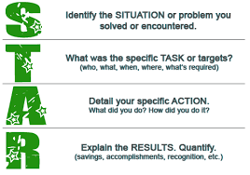
A simple example:
Interviewer: "Tell me about a time when you recognized a
problem and took steps to address it."
Your brilliant answer:
Situation: "During my internship last summer, I was
responsible for managing various events."
Task: "I noticed that attendance at these events had
dropped by 30% over the past 3 years and wanted to
do something to improve these numbers."
Action: "I designed a new promotional packet to go out
to the local community businesses. I also included a rating sheet to collect feedback on our events and organised internal round table discussions to raise
awareness of the issue with our group members."
Result: "We utilised some of the wonderful ideas we received from the community, made our internal structure more transparent, and raised attendance by 18% the first year."
Video explaining the STAR method

Now choose a behavioural question and prepare an answer, using the STAR method:
(See the “List of Interview Questions” and “List of Action Verbs”.)

Question: _______________________________________________________________________
Your brilliant answer:
Situation: ________________________________________________________________________
________________________________________________________________________________
________________________________________________________________________________
Task: ___________________________________________________________________________
________________________________________________________________________________
________________________________________________________________________________
Action: __________________________________________________________________________
________________________________________________________________________________
________________________________________________________________________________
Result: __________________________________________________________________________
________________________________________________________________________________
________________________________________________________________________________

3. Pair-work: Simulating a job interview

Find a partner. In turn, you will play the role of the recruiter and that of the candidate. As the recruiter, you will have to prepare some questions and, as the candidate, you will have to be prepared to answer your partner’s questions while controlling your body language.
(See the “List of Interview Questions” and “List of Action Verbs”.)

Class 12 - The future of job search

1. Look at different ways to find a job and decide how relevant they are today.
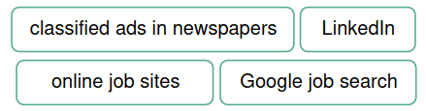

2. Complete each idea and explain your position. Make sure you understand the phrases in bold.

a) If I were to give advice to somebody who’d like to land a job in my sphere, __________________
________________________________________________________________________________
b) To me, going above and beyond in finding my next gig would mean _______________________
________________________________________________________________________________
c) Being on a job hunt today means ___________________________________________________
d) The use of AI by HR managers to sift through applications can lead to ____________________
________________________________________________________________________________
e) While job hopping might seem a bit of a negative phenomenon to some, it can also be a sign that people __________________________________________________________________________
f) Nowadays, being a good fit for a job often goes beyond just technical skills, with employers placing greater emphasis on _________________________________________________________
________________________________________________________________________________
g) In my professional sphere, what you might need to do in order to get your foot in the door is____
________________________________________________________________________________
h) With HR managers using AI to analyse applications, the best way to jazz up your résumé would be _____________________________________________________________________________

3. Read the opinions about the use of AI in the recruitment process and decide who might have expressed them. Then, say which opinion resonates with you most and why.

a) I can't help but be excited about how AI is transforming the hiring process. Hands down, it’s a game changer on so many levels. Apart from increased efficiency, AI-powered tools can also help eliminate bias in the hiring process. We all know how our own biases can influence our decision-making, don’t we? I mean, think back to ten years ago when we had to sift through stacks of résumés and conduct interviews that could drag on for weeks. Not to mention that we had to rely more on gut instincts and face-to-face interactions, which could be hit or miss, really.
________________________________________________________________________________

b) I couldn’t be more frustrated with all these AI gimmicks in the hiring process! I remember back in the day, say ten years ago, things were so much simpler. While on a job hunt, you could just submit your résumé, maybe go in for an interview, and then actually have a good chance of landing the job. But with all this AI stuff, it’s like the system doesn’t even care about my qualifications or my experience – all it cares about is some algorithmic match between my résumé and the job description. How can a machine decide whether I’m a good fit for the job? It’s not fair, to say the least!
________________________________________________________________________________
4. You’re going to watch a video about a new recruitment app which some people call ‘The Tinder for jobs’. Why do you think it is called this?
________________________________________________________________________________
________________________________________________________________________________

5. Watch the first part of the video (to 01:29) and answer the questions.

a) What was Sam doing after COVID hit?
________________________________________________________________________________
b) What inspired Sam to create a recruitment app?
________________________________________________________________________________
c) What does a job seeker need to do if they want to use getahead to find their next gig?
________________________________________________________________________________

6. Complete the notes about the getahead app based on what you have learned about it from the 1st part of the video. Watch the 2nd part (from 01:30) and check your answers.

a) Apart from creating your account, you can also use getahead to DM the companies and...
________________________________________________________________________________
b) The app has been popular with big companies and… ________________________________________________________________________________
c) Industries that are gaining the most traction include hospitality,… ________________________________________________________________________________
d) What makes getahead different from other recruitment apps is user experience and… ________________________________________________________________________________
e) The average industry hiring time is 24 days, but getahead hopes to reduce it to… ________________________________________________________________________________
f) The way the popularity of the app has been growing so far is purely organic but… ________________________________________________________________________________

7. Discuss the questions.

How helpful might the getahead app be in landing a good job in your field?
________________________________________________________________________________
Would you be interested in having a go at finding your next job using this app? Why/Why not?
________________________________________________________________________________
What are some pros and cons of using this app while on a job hunt?
________________________________________________________________________________
What are some pros and cons of using this app for employers?
________________________________________________________________________________
How might apps like getahead change the face of recruitment in the near future?
________________________________________________________________________________
How can an employer measure the success of the getahead app and its impact on the hiring process?
________________________________________________________________________________
Do you think your company would consider using the getahead app?
________________________________________________________________________________
Do you think that recruitment apps like getahead will eventually replace traditional hiring methods?
________________________________________________________________________________

8. Paraphrase the descriptions of other recruitment apps using the phrases in brackets. Make any other necessary changes.

a) Reed enables you to be the first to know about new job ads and allows you to look for jobs throughout the day, wherever you are, increasing your chances of being hired.
(be on a job hunt, sift through, land a job)
________________________________________________________________________________
________________________________________________________________________________

b) With Glassdoor, you can use the ‘Know Your Worth’ tool to adjust your salary expectations based on your experience, achievements and qualifications to end up with a job at your dream company.
(a good fit for a job, get your foot in the door)
________________________________________________________________________________
________________________________________________________________________________

c) With CareerBuilder, you can apply for jobs without creating a profile or signing in, which allows you to freely look through job listings, but you can also use it to create your CV quickly and easily and showcase it for potential employers.
(find your next gig, sift through, jazz up)
________________________________________________________________________________
________________________________________________________________________________

d) Zoek uses AI-based technology and helps you find the most relevant vacancies that correspond to your skillset so you can finally stop changing jobs frequently.
(sift through, a good fit for a job, job hopping)
________________________________________________________________________________
________________________________________________________________________________

e) Snagajob is a go-to app for you if you’re looking for a part-time or temporary job, or if you’re a student who needs flexibility around their schedule.
(on a job hunt, job hopping)
________________________________________________________________________________
________________________________________________________________________________

9. Study the spidergram and discuss the questions.

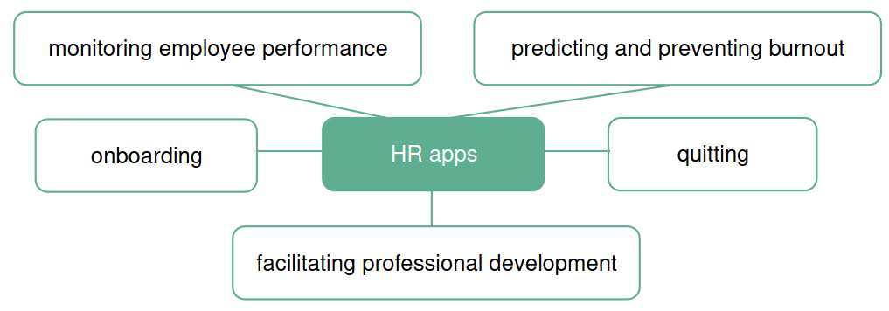
Do you know any apps that help with the HR processes mentioned in the spidergram? If not, what features might they include to make a difference in each of these processes?
________________________________________________________________________________
________________________________________________________________________________

Which of these apps, in your opinion, are already supported by AI / will soon be supported by AI / will never be supported by AI? Explain your position.
________________________________________________________________________________
________________________________________________________________________________

10. Complete the lines of a dialogue using the phrases from the lesson (initial letters are provided), then put the lines in the right order.

A: Hello! Have you heard of JobAware? It's a recruitment app that can help you l____ a great j___ in no time.
A: JobAware can definitely help with that too. Our app allows you to easily create a professional-looking résumé that will grab the attention of hiring managers as they s_____ t_____ tons of applications.
A: That's great to hear. With JobAware, you can easily search for job opportunities and filter them based on your skills and experience. We can help you find positions where you'll be a g____ f____ for the j_____.
B: Oh, interesting! I'm actually on a j___ h____ right now, so I'm definitely on the lookout for effective ways to f____ my n____ g____. B: That sounds perfect. I don't want to end up j_____ h_____ again, so finding the right position is really important to me.
A: Absolutely. And even if you're not a perfect match for a job, we can help you g____ your f_____ in the d_____ by connecting you with hiring managers and providing you with valuable interview tips.
B: That's great to know. I've been trying to j____ u____ my r_____, but it can be tough to stand out among all the other applicants.
B: That sounds like a really comprehensive solution for job seekers. I'm definitely interested in learning more about JobAware.

