Sujet EDA – 30/01/2024

Après avoir pris connaissance de l’intégralité des consignes ci-dessous, vous traiterez les différentes questions dans l’ordre proposé, en français.

Thème : « Informer et s’informer »
Classe de 1ère (cycle terminal), enseignement de spécialité « LLCER-Anglais, Monde contemporain »

À partir du corpus proposé, vous constituerez votre dossier, composé obligatoirement du document A, d’un document B, d’un document C et d’un document D. Vous annoncerez brièvement le choix opéré. Les originaux des documents sont en couleur.

1) Pour chaque document de votre dossier, vous proposerez une présentation et une analyse critique, puis vous mettrez les documents en relation en précisant comment ils s’inscrivent dans l’axe retenu.

2) Questions portant uniquement sur le document A :
a) Phonologie : : vous donnerez le schéma accentuel des mots suivants et justifierez la place des accents : presidential (l. 8), political (l. 8), conspiracy (l. 43).

b) Analyse linguistique : pour chacun des points suivants, vous décrirez et proposerez une analyse en contexte des segments soulignés :
Point 1 : in which actors may see downstream value in promoting a story without evidence (l. 31-32);
Point 2 : since that’s exactly how this whole thing got started. (l. 4-5).

c) Perspective pédagogique : en vous appuyant sur le segment analysé dans le point 2 de l’analyse linguistique, vous identifierez un objectif langagier adapté au niveau d’enseignement. Vous justifierez votre choix.

3) Question portant sur l’ensemble de votre dossier : vous exposerez les objectifs (culturels, linguistiques, communicationnels, éducatifs) que vous pourriez envisager dans le cadre d’une séquence et préciserez et justifierez l’ordre dans lequel vous proposeriez les documents aux élèves pour atteindre ces objectifs. Vous exposerez la séquence en présentant la mise en œuvre retenue (nombre de séances, objectifs et compétences travaillées, intégration de faits de langue dans la mise en œuvre, pistes envisageables d’évaluation).

DOCUMENT A
Derek Thompson, “The Clickbait Presidency.” The Atlantic, March 6, 2017.
<https://www.theatlantic.com/politics/archive/2017/03/the-clickbait-presidency/518751/>

The Clickbait Presidency
The Donald Trump conspiracy-theory feedback loop is only going to get worse.
President Donald Trump’s accusation on Twitter that Barack Obama ordered a wiretap on his residence has been denied by the former president, rebutted by the FBI director, and criticized by Republican lawmakers. But it’s hardly surprising that Trump’s presidency has been mired in groundless conspiracy theories, since that’s exactly how this whole thing got started.
Even before he was a Republican presidential candidate, Trump’s modern political career kicked off with unfounded, and repeatedly disproved, rumors about Barack Obama's birth certificate. It continued when he became president-elect, as Trump fixated on the size of his inauguration crowd, arguing against all evidence that it was larger than the record crowd that showed up in 2008 to see President Obama sworn in. Now, as president, he has claimed that Hillary Clinton won the popular vote only because of several million illegal voters, none of whom the White House has been able to identify.
After the election, there was much hand-wringing in the media about journalism being lost to a surge of fake news--confirmation-bias candy built to attract clicks from gullible readers. But what about a marketplace for alternative facts and fake news created for and by the president himself?
In theory, the president of the United States incorporates the exclusive intelligence to which he has access into existing theories about the world, and uses it to craft policy. In practice, however, Trump appears to execute this sequence in reverse. He begins with a worldview in which all unhappy news is a plot against him, seeks out cable-news chyrons and headlines that animate his theory, and ignores any information to the contrary, even from his own intelligence agencies. After FBI Director James Comey asked the Department of Justice to discredit the president's “Obamagate” theory, Trump's spokeswoman told ABC that the president doesn’t believe the FBI.
This latest fictitious Obamagate theory was perhaps first proposed by Mark Levin, a conservative radio host. It received amplification from Fox News host Sean Hannity, Rush Limbaugh (who called it a “silent coup”), and a Breitbart columnist, Joel Pollak, whose column made the rounds in the Trump White House, as Brian Stelter reported. In other words, the news did not go viral so much as it pinged from one right-wing outlet to another, each lending credence to the story until Trump delivered the ultimate, news-cycle-busting broadcast.
This is a conspiracy-theory feedback loop, in which actors may see downstream value in promoting a story without evidence, not only because they think it will please conservative audiences, but also because it may eventually prompt an invaluable Trump endorsement. If you thought the incentives for “click bait” headlines were bad, imagine the incentives for “Trumpbait” news. Small-scale commentators and individual writers seeking national glory will see value in competing to construct the next “Obamagate.” If you are an ambitious writer watching the last 72 hours unfold, the obvious implication is that the president is scanning for stories that tarnish the legitimacy of his enemies in the media and the Democratic Party, and he will lavish valuable attention on the most sensational theories, whether or not they offer even the pretense of evidence for their claims.
In the long run, this conspiracy machine may prove disastrous for both Trump and the media companies whose stories he shares. For now, the value of advertising space for the Fox News shows the president watches has soared, as shows like Hannity broadcast the president’s message, and he tweets their best lines. But other news sources that rely on advertising may find that large companies don’t want their names anywhere near uncritical coverage or pro-Trump conspiracy theories. For example, an online activist campaign against Breitbart caused more than 900 companies to block the company from their programmatic ads buys. Individual writers may derive massive satisfaction in writing the sort of story that whirs through the White House printers. But at the corporate level, Breitbart may come to see that massive attention is not always massively marketable.
As for Trump, Americans are still learning what it means to have a president who is essentially a one-man media conglomerate, who processes the world through ratings and media representations of strength, and whose ultimate political goal sometimes seems to be avoiding looking like a fool, even when it means distributing ideas so unfounded that his own White House won’t back them up.
Some people imagine political propaganda as a top-down operation, in which the government beats down critical journalism and builds a machine of sycophancy to take its place. But propaganda in the age of Trump can self-assemble from the bottom-up. There’s no need to build 21st century Pravda; left unaided, attention-driven economics and status-seeking individuals who’d get a kick out of seeing the president tweet their essay will gladly write outrageous stories, designed to appeal to Trump's conspiratorial worldview, for the clicks. The propaganda will self-propagate, and the president won't even have to request it. That is what you might call an efficient market—just not for the truth.

DOCUMENTS B
B-1. A political cartoon by Tom Janssen. Herald Courier, January 12, 2017. <https://heraldcourier.com/opinion/cartoon-trump-fake-news/image_39e2a320-d6ec-11e7- a0a5-ef89984c0352.html>
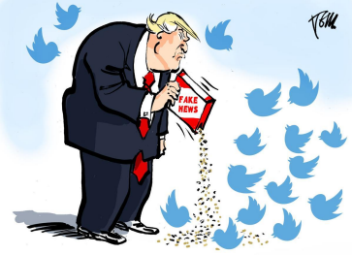

B-2. “What Elon Musk Really Believes”. TIME, 26 April, 2022.
< https://time.com/magazine/us/6171751/may-9th-2022-vol-199-no-17-u-s/ >
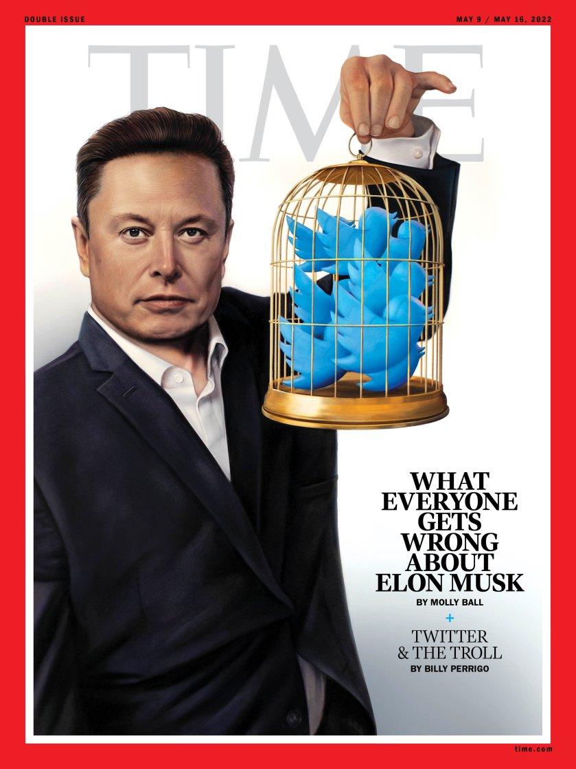

DOCUMENTS C
C-1. CITS. “Protecting Ourselves from Fake News: Games that Teach about Fake News”. The Center for Information Technology and Society (CITS) is a multidisciplinary endeavor at University of California, Santa Barbara whose goal is to apply the knowledge of diverse perspectives to understand the development, use, and effects of information technologies in contemporary society.
<https://www.cits.ucsb.edu/fake-news/protecting-ourselves-teach>
Protecting Ourselves from Fake News: Games that Teach about Fake News
Another way you can help stop the spread of fake news is to learn more about the way it works. While we hope our website’s given you some good information about how fake news is created, spread, and why people fall for it, reading about fake news can only do so much. Some online resources exist that can help you train yourself to investigate suspicious news, and get first-hand experience with how the fake news process works. A number of games exist to train and sensitize readers to detect and stay immune to fake news […].
Fake It to Make It
Fake It to Make It […] puts the player in the role of the creator of fake news, trying to make money from advertisers by setting up a site, copying news stories and re-posting them, creating fake social media accounts and generating interest by choosing users and groups to target with social media messages. It provides a running tally of how much attention your website has
gotten and how much money you’ve made. You quickly get a sense of what questionably ethical strategies work best – it’s amazing how low you can sink, how quickly, to start winning!
Fake It to Make It teaches players how fake news peddlers monetize their sites.

C-2. “Yellow Journalism”, a podcast by Severin de Wit (a lawyer and consultant in an international consultancy in Intellectual Property, IPEG).
< https://trusttalk.co/journalism/yellow-journalism/ >


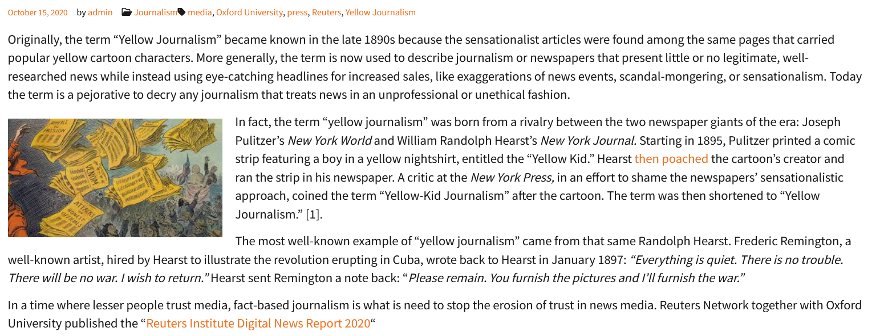

DOCUMENTS D
D-1. GOURAUD, Erwan (2019, Dir.). Let’s Meet Up 1ère. Paris: Hatier.
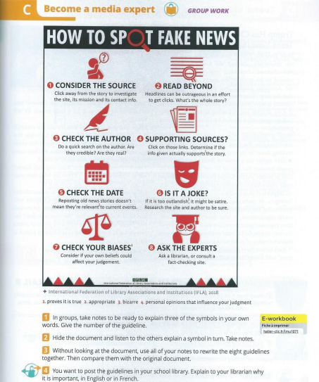

D-2. COGHLAN, Annie, MORO, Bernard, HERMENT, Mélanie, CORBÉ, Jérémy, MATHIEU, Cindy, WALLACE, Mark, WALTERS, James, MENENTEAU, Anne, DAVIGNON, Frédéric (2019). In Full Swing 1ère. Paris: Didier.
