**Class 4 - The written CV**

**1. Warm-up**

**Decide which of these you would include in a CV and which you would not.**

Give reasons for your answers.

* your photo
* your home address
* your hobbies
* any work experience you have had
* the name of the school/university you went to
* your gender
* your marital status
* your biggest achievement
* a list of languages you speak
* your date of birth

**2.  Advice for CVs**

**Explain what the speakers in a–e mean by matching the statements with their follow-ups 1–5.**

a) “I use online CV templates.” 3

b) “I like to use bullet points in my CV.” 5

c) “When I write about my work experience, I put the information in chronological order.” 4

d) “I only write about relevant experience and education.” 2

e) “I put my CV objective at the top of the CV and it is usually very short.” 1

1) “I write a couple of sentences about myself and my career goals.”

2) “For instance, I once did a painting course but I won’t write about it if I decide to try and get a job in accounting.”

3) “They have nice designs and when I use them I don’t have to think about details like where to put my email address.”

4) “This way, the most recent job is at the top and the first job is at the bottom.”

5) “I can use them to clearly list what my jobs involved.”

**3. Mistakes on CVs**

What do you think are the main sources of CV rejection?

Explain the figures in the infographic.

Give examples and predict how an employer could react.

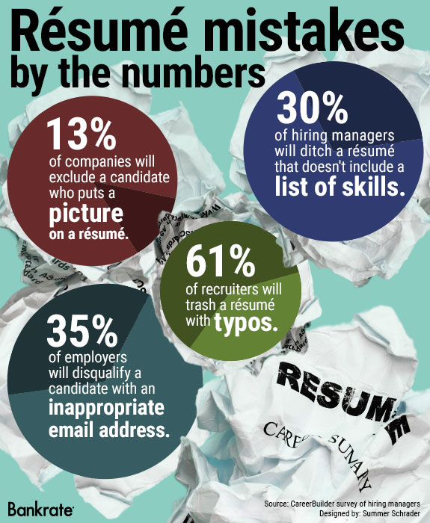

|  |  |  |
| --- | --- | --- |
|  | Examples of mistake | Employer’s predictable reaction |
| picture | a photo that shows me in a group of people | “Where is the applicant in the photo?” -> puzzled |
| list of skills | too long list | “I don’t want to read everything” -> bored |
| typos | wrong spelling of job roles or company names | “This person can’t write” -> annoyed |
| email address | fun, unprofessional email address | “This person is not serious” |

Then, brainstorm three more mistakes frequently made by candidates and how employers might feel about them.

1. not mentioning skills next to job roles -> employer will not know what skills you gained

2. using a fancy design -> might not even reach a human recruiter, might annoy them

3. using humour -> might annoy the recruiter

**4. Video “Résumé basics”**

**Watch the first part of a video (00:00 to 01:23) about writing a résumé (another word for CV) and match the types of résumés with the statements.**

[Resume Basics | Tips for Resume Format, Type, and Sections](https://youtu.be/KKJnZSCH1ko)

This type of résumé is good for people who have had a long break from work. [00:42] - functional résumé

Your skills are as important as your work experience in this résumé. [01:01] - combination résumé

In this résumé the earliest experience is written at the bottom. [00:26] - chronological résumé

**Watch the second part of the video (from 01:24–02:58) and decide if the statements are true or false according to the speaker. Correct the false statements.**

a) You have to include your phone number in the contact information section. T [01:37]

b) The résumé objective should say something about your skills. T [01:42]

c) You should write at least two bullet points under each job title. F You should write between three and five bullet points. [01:56]

d) You should only list soft skills. F You should include both hard and soft skills. [02:02]

e) You don’t have to write where your school/university is. F You should write where your school/university is. [02:29]