

WORKBOOK

ENGLISH COURSE - L3 S5

The CV - Job interviews

Droits d’utilisation :
Ce livret a été conçu uniquement à destination des étudiants de Licence 2 Informatique de l’Université d’Orléans. Toute ré-utilisation est soumise à l’accord des auteurs.

Contents

Class 1 Class organisation - How to make a video CV -Written CVs

Class 2 Choosing careers - IT jobs

Class 3 Get your CV past the bots - Graduate assessment centres

Class 4 Body language

Class 5 Skills (1)

Class 6 Skills (2)

Class 7 CC1: written test

Class 8 The job interview (1)

Class 9 The job interview (2)

Class 10 The future of job search

Assessment

CC1 - Written test (50%)
Duration : 1h30
Questions about grammar and vocabulary
Questions about the content of classes 1 - 8
Reading comprehension

CC2 - Video CV (50%)
You are going to introduce yourself in English to a potential employer, in a short video.
You will not use notes. The clip will be 1'30 to 2’ long.
Shoot your own video and send it in through CELENE
(Read Filming Guidelines first)
Deadline: …………………………………………..

Contacts
anne-cecile.alzy@univ-orleans.fr
murielle.pasquet@univ-orleans.fr
adfaucheux@stpbb.org

Class 1 - Class organisation

How to make a video CV – Written CVs

1. Class organisation
Presentation of schedule, assessments, etc.

2. How to make a video CV (CC2)

Watch a tutorial and a sample video profile. How To Make A Video Resume

Your video profile is the ideal complement to your CV because there are ____________,
______________ of candidates applying for the same position. With a video profile, you will _________________________________.
Before you start, ask yourself these questions:
- What _________________________________________________________?
- What are your __________________________________________________?
- What is your _______________, what _______________________________________?
- What are your ______________, what _______________________________________, what makes you special?
- How would you _________________________________________________?

Structure :
1. Establish warm contact, thank viewers for watching and potentially considering you for employment
2. Introduce yourself : name, age, current occupation, background
3. Present your professional objective, the type of position you are looking for
4. Describe your major strengths
- qualities: why you would be a good employee, what you can do for the company that hires you
- training, professional experience (placements, employment...)
- personal experience (voluntary work, sports, foreign languages and travelling...) if relevant
5. End the talk with a strong statement ! Show that you wish to get in touch with recruiters. Mention contact details or your professional website / page.

TIPS : → use spoken English
→ your video may be seen by multiple employers, so don't be too specific
→ time yourself to stay within the time limit

Sentence match: match the beginnings and the endings of these sentences

A - “beginnings”
First of all I’d like to thank you for considering my application ...
I want to improve my current skills in different technologies ...
I have previous experience in software development ...
In my last internship, I learned how to listen to people ...
Right now I'm looking for a 6-month internship ...
At work, I am resourceful, reliable, dedicated I like to challenge myself and that’s why ...
My previous internship supervisors have always trusted me ...
I led a 6-person team during a semester project last year I am a volunteer fireguard, ...
If you’re interested in my profile, ...
Please let me know if you have any further questions for me ...

B - “endings”
… or if you’d like to meet face-to-face.
… and I can adapt easily to any type of environment.
… and we succeeded in releasing a well-finished product.
... I went to study in Poland during one semester as part of my studies.
… and I’ve often been hired for a summer job after a training period.
… and for taking the time to look at my video profile.
… please get in touch with me at ...@...
… as well as earn new ones.
… which proves I am committed and reliable.
… from my internship in Sopra in the last year of my Bachelor's degree.
… and provide solutions to match their expectations.
… in a company where I would be contributing to large projects.

Now prepare your video profile in writing

1. Making contact
________________________________________________________________________
________________________________________________________________________
________________________________________________________________________
2. Self-introduction
________________________________________________________________________
________________________________________________________________________
________________________________________________________________________
3. Professional objective
________________________________________________________________________
________________________________________________________________________
________________________________________________________________________
4. Strong points / Experience / Personal qualities
________________________________________________________________________
________________________________________________________________________
________________________________________________________________________
5. Ending
________________________________________________________________________
________________________________________________________________________
________________________________________________________________________
Formal and friendly ways of introducing yourself and the subject of your presentation. For each formal sentence, choose an expression you would feel more comfortable using.

a) Well, perhaps we should begin. ____________________________________________
________________________________________________________________________

b) Good morning, ladies and gentlemen ________________________________________
________________________________________________________________________

c) On behalf of …, may I welcome you to… ___________________________________
________________________________________________________________________

d) My name is….. ________________________________________________________
________________________________________________________________________

e) For those of you who don’t know me already,... ________________________________
________________________________________________________________________

f) This morning I’d like to … _________________________________________________
________________________________________________________________________

g) Perhaps we can leave any questions you may have until the end of the presentation. ________________________________________________________________________
________________________________________________________________________

3. The written CV

1. Decide which of these you would include in a CV and which you would not.

Give reasons for your answers.
- your photo
- your home address
- your hobbies
- any work experience you have had
- the name of the school/university you went to
- your gender
- your marital status
- your biggest achievement
- a list of languages you speak
- your date of birth

2. Advice for CVs

Explain what the speakers in a–e mean by matching the statements with their follow-ups 1–5.

a) “I use online CV templates.” ___
b) “I like to use bullet points in my CV.” ___
c) “When I write about my work experience, I put the information in chronological order.” __
d) “I only write about relevant experience and education.” ___
e) “I put my CV objective at the top of the CV and it is usually very short.” ___

1) “I write a couple of sentences about myself and my career goals.”
2) “For instance, I once did a painting course but I won’t write about it if I decide to try and get a job in accounting.”
3) “They have nice designs and when I use them I don’t have to think about details like where to put my email address.”
4) “This way, the most recent job is at the top and the first job is at the bottom.”
5) “I can use them to clearly list what my jobs involved.”
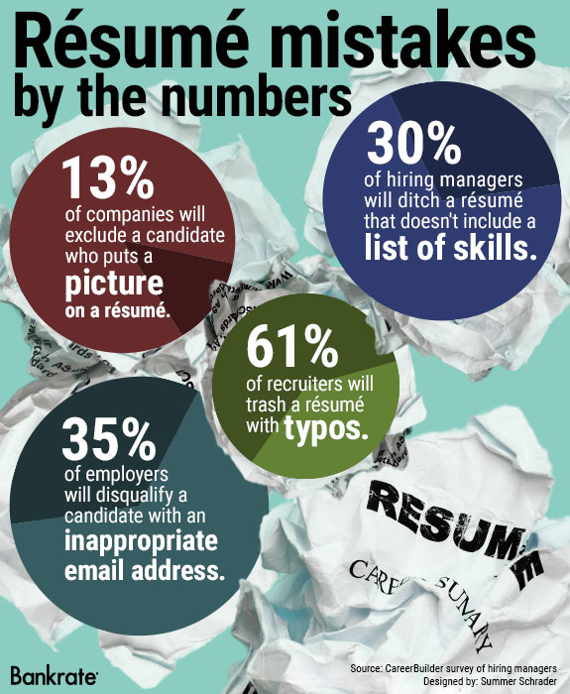
3. Mistakes on CVs
What do you think are the main sources of CV rejection?
Explain the figures in the infographic.
Give examples and predict how an employer could react.

 | Examples of mistake | Employer’s predictable reaction
picture | ____________________________  ____________________________ | ____________________________  ____________________________
list of skills | ____________________________  ____________________________ | ____________________________  ____________________________
typos | ____________________________  ____________________________ | ____________________________  ____________________________
email address | ____________________________  ____________________________ | ____________________________  ____________________________

Then, brainstorm three more mistakes frequently made by candidates and how employers might feel about them.
1. ______________________________________________________________________
________________________________________________________________________
2. ______________________________________________________________________
________________________________________________________________________
3. ______________________________________________________________________
________________________________________________________________________

4. Video “Résumé basics”

Watch the first part of a video (00:00 to 01:23) about writing a résumé (another word for CV) and match the types of résumés with the statements.

Resume Basics | Tips for Resume Format, Type, and Sections

This type of résumé is good for people who have had a long break from work. __________
________________________________________________________________________

Your skills are as important as your work experience in this résumé. __________________ ________________________________________________________________________

In this résumé the earliest experience is written at the bottom. ______________________
________________________________________________________________________

Watch the second part of the video (from 01:24–02:58) and decide if the statements are true or false according to the speaker. Correct the false statements.

a) You have to include your phone number in the contact information section.
________________________________________________________________________

b) The résumé objective should say something about your skills.
________________________________________________________________________

c) You should write at least two bullet points under each job title. ________________________________________________________________________

d) You should only list soft skills.
________________________________________________________________________

e) You don’t have to write where your school/university is.
________________________________________________________________________

Class 2 - Choosing careers / IT jobs

1. Video “Choosing careers”

1/ What adjective does the journalist use to describe choosing a career? And what does it mean? dreaded (= feared / redouté)
_____________________________________________________________________________
_____________________________________________________________________________

2/ What will this decision affect? ___________________________________________________

3/ Why does the journalist say that choosing a career is “especially hard”?
_____________________________________________________________________________

4/ Cath Roan, Managing Director careershifters.org, says that most people choose their first job quickly. What negative comparison does she make?
_____________________________________________________________________________
_____________________________________________________________________________

5/ Why might some students be tempted to take the job that offers the highest paycheck according to Ms Roan?
_____________________________________________________________________________
_____________________________________________________________________________

6/ What two problems does Terry Jones indicate?
Problem 1: you don’t know what’s _________________________________________________
Problem 2: you don’t really know what’s ______________________________________________

7/ What does he think is important for everyone to do?
_____________________________________________________________________________

8/ According to Mr Jones what are people ready to accept?
_____________________________________________________________________________

9/ Explain what happened to someone Ms Roan met through work.
_____________________________________________________________________________
_____________________________________________________________________________

10/ Look at this part of the script. How would you translate the underlined word into French?
“Research shows emphatically that people are actually conditioned to do what is expected of them and this is where so many people go wrong, so rather than doing what’s expected of you, if you actually do what feels right for you then you’ve got a greater chance of success.”
emphatically : _________________________________________

11/ What expression does the journalist use to indicate that something seems like a good idea but it would be difficult to do?
_____________________________________________________________________________

12/ Look at this part of the script. How would you translate the underlined word into French?
“But how do people figure out what’s right for them?”
_____________________________________________________________________________

13/ What expression did Ida Rezvani use? Fill in the gap.
“Because there may be something in the ___________________ of your stomach that says:” You know what, I’ve got to be an astronaut”, and if that’s what it is, you should go all out to do that.

14/ What is a value set? How is it described in the report?
_____________________________________________________________________________
_____________________________________________________________________________

15/ Fill in the gaps:
To be honest, that _________________ like it’s going to take up a lot of __________________, can’t you just do it for the money?
Don’t do it for the money because if you come in here and you sit here for 12 hours a day just because you think you’re going to ________________ a dollar and it’s not the thing that you love, first of all you will be ______________ and no amount of money can compensate for the _______ and second of all you will be _____________ at it because you’re not enjoying it and so you won’t actually end up earning any money ________________.

16/ Trevor Jones says that there are two approaches to graduate jobs, what are they?
People interested in: ____________________________________________________________
People interested in: ____________________________________________________________

(STOP 3:43)

2. Grammar: Indirect questions

Questions can be introduced by statements. In this case we do not use inverted word order for a question, or auxiliary words, or a question mark. These questions are generally called indirect questions.

I was wondering when the train leaves. I’d like to know what her name is.
It’s not clear what I write here. I’m not sure who I’m talking to.

In indirect questions the verb usually changes to the past:
How old are you? She asked me how old I was.

1) Here are some of the questions you were asked at an interview for a job (you can start with: she wanted to know whether / she enquired):

a. What do you do in your spare time? _____________________________________________________________________________

b. Can you use Java Script? _____________________________________________________________________________

c. Why did you apply for the job? _____________________________________________________________________________

d. Have you got a driving licence? _____________________________________________________________________________

e. How long have you been studying IT?_____________________________________________________________________________

2) Complete the sentence so that it contains an indirect question and means the same as the first sentence.

a. What time does the lecture finish?_____________________________________________________________________________

b. Where is the projector?_____________________________________________________________________________

c. How does this work? _____________________________________________________________________________

3) Find a mistake.

a. She asked me where do I come from. _____________________________________________________________________________

b. Tell us how much do you expect to earn. _____________________________________________________________________________

3. IT jobs

Think about these questions

• What kind of people do IT jobs?
• What sort of companies or industries would they work in?
• What skills and qualities would someone need to succeed in an IT job?
• Name some negative traits that wouldn’t help someone in a tech job.

Study the job descriptions (job roles) given by your teacher and:

1. guess the job title

2. select some skills and qualities in the following list that are most needed for this position.

Eye for detail / Strong attention to detail / Meticulous
Keen / Motivated
Creative / Innovative
Able to work under pressure / Able to thrive in a fast-paced working environment / Hard working
Can-do attitude / Proactive
Synthetic mind / Able to see the bigger picture
Communication skills / Interpersonal Skills / Good communicator
Can think from a customer view point
Understanding a team’s needs / Teamworker
Likes to solve problems
Able to work with large amounts of data
Knowledge of design software / Knowledge of marketing / Knowledge of financial services / Knowledge of application development languages

Job role 1
I think this job role is: ___________________________________________________________
Skills and qualities needed: ______________________________________________________
_____________________________________________________________________________

Job role 2
I think this job role is: ___________________________________________________________
Skills and qualities needed: ______________________________________________________
_____________________________________________________________________________

Job role 3
I think this job role is: ___________________________________________________________
Skills and qualities needed: ______________________________________________________
_____________________________________________________________________________

Job role 4
I think this job role is: ___________________________________________________________
Skills and qualities needed: ______________________________________________________
_____________________________________________________________________________

Class 3 - Get your CV past the bots

Graduate assessment centres

1. Warm-up

Answer the questions, and then share your answers.

1. What font and font size do you usually use when you write something for work?
E.g. Arial 12 or Calibri 11

2. Why do you use that font and font size?
E.g. - out of habit / because it’s the one I’ve always used
- because it’s what my boss wants
- because it is the cleanest / most professional / easiest to read

3. What font and font size do you use on your CV?

4. When did you last update your CV?

2. Key words

Match the key words and expressions with the definitions below. Find and underline them in the article to see how they are used in context.

achievement applicant bot candidate column
get fancy industry term mess recruiter
screen skim remove from the equation

1. someone who applies for a job ___________________________________________________
2. someone whose job is to get someone to work in a company ___________________________
3. get information in order to decide whether someone is suitable for something, for example a job ______________________________________________________________________________
4. someone competing for a job ____________________________________________________
5. a computer program that works automatically, especially to find information ________________
6. not consider for something ______________________________________________________
7. short lines of writing or numbers arranged one below the other on a page _________________
8. do something that is too unusual or stands out ______________________________________
9. chaos, when things are very unclear ______________________________________________
10. something that you have managed to do by working hard _____________________________
11. read something quickly and not very carefully ______________________________________
12. a word or expression that is typical for one type of business ___________________________
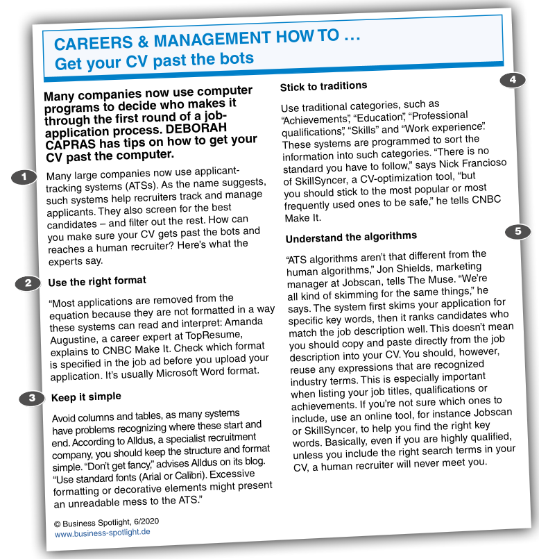

3. Understanding the article

Decide whether the statements are true (T) or false (F) according to the article.
Correct any that are false.

1. You should use different fonts and put images in your CV to make it stand out.
_____________________________________________________________________________

2. Many large companies now use human recruiters to skim applications before they get passed onto bots.
_____________________________________________________________________________

3. Include categories and headings that the ATS expects to find.
_____________________________________________________________________________

4. Copy and paste words from the job ad into your CV to make it more industry specific.
_____________________________________________________________________________

5. Check the job ad to see if you should use a specific font in your application.
_____________________________________________________________________________

4. Vocabulary

a. Complete the table with words from the article.
person | noun | verb
an applicant | ____________________________ | ___________________________
a recruiter | ____________________________ | ___________________________
an advertiser | ____________________________ | ___________________________

b. Complete these questions with the best words from task a.

1. When did you last apply for a job? _______________________________________________
2. Where did you see the job advertisement ? ________________________________________
3. How did you send your application ? ______________________________________________
4. Did you talk to a human recruiter ? _______________________________________________

5. Video “Graduate assessment centres”

1.Look at the following sentences. How would you translate the two underlined words?
So your CV managed to get you a telephone interview and you didn’t muck it up, so you’ve been invited back to the all important assessment centre. Now this really is the final hurdle guys, so I asked my CareerPlayer friends for some advice.
muck up = ____________________________________________________________________
hurdle = ______________________________________________________________________
2.Who do the following people work for / what are their jobs?
 | job / department | company
James Meachin | ____________________________ | Pearn Kandola
Janet Cowell |  | __________________________
Michael Weary | ____________________________ | UBS Investment Bank
Matt Sevenoaks | Forensic department | __________________________
3. How long does a candidate stay at an assessment centre? ____________________________

4. What might a candidate be asked to do?
- ________________________________________________________________________
- ________________________________________________________________________
- ________________________________________________________________________

5. What does the final example of an activity/exercise involve?
_____________________________________________________________________________

6. What might the exercise be?
It might be a ________________________________________________ where you are having a _________________________________________ about a business problem.
It might be a _______________________________________ we are presenting to other people.
It might be a written exercise where you are asked to give your __________________________ on a particular type of business problem.
7. Why are these given?
_____________________________________________________________________________

8. What sort of performers must they be? ____________________________________________

9. What do a lot of companies say about graduate recruiting?
_____________________________________________________________________________

10. In a competency based interview, what are all the questions going to be around?
- ________________________________________________________________________
- ________________________________________________________________________

11. Gap Fill:
To succeed at a competency based interview you need to know what kinds of things _____________________ are looking for. That’s quite easy to find out. Generally there are a similar set of ______________________. Once you’ve really ____________________ what those things are, you can then look at what your experiences are and try and ____________________ those to those specific areas employers are interested in. Probably the biggest way ___________ can stand out in my experience is actually having something _________________ to talk about that’s very work _______________. An awful lot of graduate __________________ hear very similar examples of experience from candidates especially where candidates talk about their ____________________ and their exams. Answer the question that you’ve actually been asked and I think that is a really big mistake that many people make is that you go off at a ___________.

12. What is an e-tray exercise?
- ________________________________________________________________________
- ________________________________________________________________________

13. What may happen at the end of the e-tray exercise?
_____________________________________________________________________________

14. And why is this done?
_____________________________________________________________________________

15. What advice is given about giving presentations?
- ________________________________________________________________________
- ________________________________________________________________________
- ________________________________________________________________________

16. According to the report there are two important aspects to a presentation:
- ________________________________________________________________________
- ________________________________________________________________________

17. What should you not be during your presentation?
_____________________________________________________________________________

18. Look at the script for this part of the report. How would you translate the underlined word?
Lastly, group exercises. Is it all about team-bonding and being the keenest person in the room?
keenest = ____________________________________________________________________

19. What is one myth about group exercises?
_____________________________________________________________________________

20. What really matters to an organisation?
- ________________________________________________________________________
- ________________________________________________________________________

21. What expression (phrasal verb) used in the report means when someone does not listen to what someone else is saying and carries on speaking without paying attention.
_____________________________________________________________________________

22. According to the report, what do assessment centres create and what is their aim in so doing?
Create: _______________________________________________________________________
Reasons: 1. _________________________________________________________________
2. _________________________________________________________________

23. What expression is used to improvise, to do something without preparation?
_____________________________________________________________________________

24. What is a big mistake that candidates often make?
_____________________________________________________________________________

Class 4 - Body language

1. Warm-up
Nonverbal communication makes up about two-thirds of all communication between two people or between one speaker and a group of listeners. So body language is important.
How much do you know? Match the gestures with their meanings

Torso
c
a
b
1. torso forward

2. torso backwards

3. torso upright

b
c
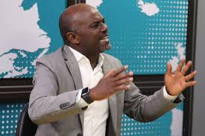a
Hands and arms

1. Hiding hands

2. Palms held out, upwards
e
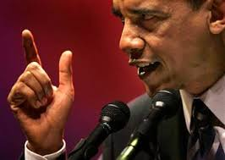d
3. Palms down

4. Arms apart, palms parallel, cutting
f
5. Palms moving up and down
g

6. Palms downwards sideways

7. Pointing (with finger)

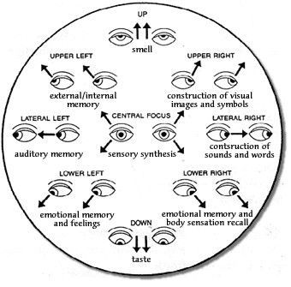
Eyes

1. looking right

2. looking left

3. direct eye contact (when speaking)

2. Video “Your body language may shape who you are”

Give an equivalent or a translation for these words from the video.

words from video | equivalent | words from video | equivalent
______________ | innovative change | ______________ | a result, a consequence
______________ | to reveal | ______________ | a doctor
______________ | to bend your body | ______________ | to take to court
______________ (informal) | to make a minor change | ______________ | striking
______________ | embarrassing | ______________ | de gouverneur
______________ | méprisant, dédaigneux | ______________ | orgueil, fierté
______________ | un clin d'oeil | ______________ | the fact of being able to see
______________ | a deduction | ______________ | s’enrouler dans qqch

Watch the Ted video and answer the questions.

1. What does Amy Cuddy want her audience to do?
_____________________________________________________________________________

2. What is interesting to observe in others' body language?
_____________________________________________________________________________

3. Which term is used by scientists for 'body language’?
_____________________________________________________________________________

4. What can be predicted simply by watching someone's body language?
_____________________________________________________________________________

5. Explain the anecdote with the doctor.
_____________________________________________________________________________

6. What about political candidates?
_____________________________________________________________________________

7. Who else is influenced by non-verbals?
_____________________________________________________________________________
8. What's her job? What does she study? Where does she work?
_____________________________________________________________________________

9. What is she especially interested in?
_____________________________________________________________________________

10. How do animals and humans express power?
_____________________________________________________________________________

11. How do people express their pride of winning at a physical competition?
_____________________________________________________________________________

12. What unexpected category of people does the same thing?
_____________________________________________________________________________

13. What happens when we feel powerless?
_____________________________________________________________________________

14. What happens when we are facing someone powerful?
_____________________________________________________________________________

3. Video “Body language in a job interview”

Complete the 10 tips

1 Greet modestly with an equal handshake
It’s always difficult greeting someone for the first time. Humm, a little aggressive. Your interviewer knows you want the job so don’t ________________ them with an _________________ gesture. Avoid noise flicking, high fives, air kisses or jazz hands. Play it simple and ________________
________________ to avoid dominant vibes.

2 Relax into your chair
The interviewer will show you to your chair. This is the all important hot seat and the way you sit conveys a lot of information. Take a moment to position and _________________ ...but not too comfortable. Look relaxed. It encourages your interviewer to feel at ease in your company. However, no matter how informal the discussion, avoid ________________. You’re not at home watching the telly now.

3 Don’t form body barriers
An interview is not the time to come over all shy and retiring. ____________________ across your chest or ________________________ conveys a nervous, negative or even aggressive attitude. That’s it! Use your upper torso to define an open and honest attitude. Keep the back straight and________________________ to demonstrate interest.

4 Keep your hands away from your face
Children cover their mouths when they’re telling lies. As we get older, this subconscious habit turns into __________________, __________________ or the tweaking of the tool shed. If you’re stroking the nose, caressing sideburns or chin scratching, these actions can make your interviewer feel ________________. Right! Avoid touching your face by keeping your hands ________________ or relaxed in your lap.

5 Stay focused
It’s important to concentrate during your interview. Stop ______________________or repetitive looks to the floor or ceiling. By moving the eyes around the room, you risk looking ____________, _________________ or just plain ______________. Give your interviewer your full attention. Look and listen.

6 Sit still
During the interview, don’t transfer your butterflies into _______________, like ______________. Watching your legs perform a neat rendition of Riverdance under the table is one distraction the interviewer doesn’t need. Channel your nerves into ________________, yet ________________ hand gestures to endorse what you say.

7 Stop being picky
Yes, that’s a nice tie but ____________________ or grooming of your garments conveys an element of ________________ or ________________. Even if you’re certain there’s a speck on your clothes, leave it alone. No one else will notice but you.

8 Maintain eye contact
Keep your eye contact ________________ and ________________… but remember to blink. An interview can be intense so avoid adopting a serial killer stare. Instead ________________ ______________ on your interviewer’s face and look within that zone. Try not to _____________
___________ below the triangle though. Any further south and things start to get a little intimate.

9 Steer your body
Crossing your legs during the interview is agreeable and will not appear as ________________ as crossing your arms. It’s useful if you ________________ the interviewer with your knees or your feet. This will help you position your body so you’re ________________ on them alone. But don’t overdo it.

10 Use your hands
Being physically expressive as you speak shows ________________ in what you’re saying. Use your hands to ________________ answers or ________________ to your ideas. That’s it! The interviewers think that you know what you’re talking about. However, don’t exaggerate the gestures. You’re not breaking moves at the local discotheque. And avoid __________________. Instead, motion with your hands ________________ as this signifies an offering gesture.

4. Body language preparation for the video profile

Here are some basic principles that you need to keep in mind:

1 Body language in general

Hands and arms gestures must start from you towards the audience (shows willingness to share and open mindedness), below your face, above the desk.
Eye contact is of course essential and must be expressive.
Any object you place between you and the audience may indicate you place an “obstacle” or protect yourself.

2 Voice

• Make it expressive and interesting by varying intonation and pace.
• When stressed out, people have a tendency to speak too fast. Be aware of your own pace and, if necessary, slow it down (by 20%).
• Lower your voice. This will give more meaning to what you are saying.
• Pause before and after important words or phrases.
• Make sure your voice does not go up at the end of sentences. This would create doubt in what you are saying.
• Articulate
• Speak up. Avoid mumbling. Be confident. What you are saying is interesting.
• Make sure you pronounce the names of degrees, places, schools correctly

Class 5 - Skills (1)

1. Warm-up

Can you give some examples of skills (e.g. camping skills: building a campfire, putting up a tent)?

English skills __________________________________________________________________
_____________________________________________________________________________

Life skills _____________________________________________________________________
_____________________________________________________________________________

Communication skills ____________________________________________________________
_____________________________________________________________________________

• Which skills do you have?
• Which skills did you develop when you were a child? Did anyone teach you these skills?
• Which skills would you use at work? Give some details.
• Which skills would you like to work on? Why?
• How could someone improve their:
- presentation skills?
- communication skills?
- computer skills?

Look at the pictures. What is the difference between hard and soft skills?
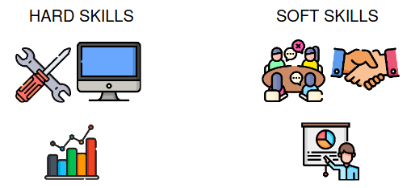

2. Video

Watch a video about hard and soft skills and check your ideas.

_____________________________________________________________________________
_____________________________________________________________________________
_____________________________________________________________________________

Decide which sentences are about soft skills and which are about hard skills. Then, watch the video again and check your answers.

a) You can’t do your work without them. _____________________________________________
b) They are also called ”people skills”. _______________________________________________
c) Communication is an example of this type of skill. ____________________________________
d) You can learn them in school or when you work. _____________________________________
e) You need to practise them with other people. _______________________________________
f) You can measure them easily. ___________________________________________________
g) You need them if you want to be successful in your job. _______________________________

Match the halves to create different skills.

a) being a ___________________________
b) being a team ______________________
c) project ___________________________
d) driving a __________________________
e) being ____________________________
f) time ______________________________
g) public ____________________________
1) player
2) creative
3) good leader
4) management
5) management
6) speaking
7) car

Look at the skills in the previous exercise and discuss the questions.

• Which of the skills are hard and which are soft? If you think that some skills can be both hard and soft, explain why.

Hard skills: __________________________________________________________________
____________________________________________________________________________
Soft skills: ___________________________________________________________________
____________________________________________________________________________

• Why are soft skills important in a workplace?
_____________________________________________________________________________
_____________________________________________________________________________

• Should soft skills be a school subject? Why/Why not?
_____________________________________________________________________________
_____________________________________________________________________________

• Is it easier for you to develop soft or hard skills? Can you give examples?
_____________________________________________________________________________
_____________________________________________________________________________

Vocabulary exercise

noun | adjective (“I am …”) | meaning (“I can …”)
self-confidence | ________________ | ___________________________________________  ___________________________________________  ___________________________________________
trustworthiness | ________________ | ___________________________________________  ___________________________________________  ___________________________________________
empathy | ________________ | ___________________________________________  ___________________________________________  ___________________________________________
assertiveness | ________________ | ___________________________________________  ___________________________________________  ___________________________________________
inquisitiveness | ________________ | ___________________________________________  ___________________________________________  ___________________________________________

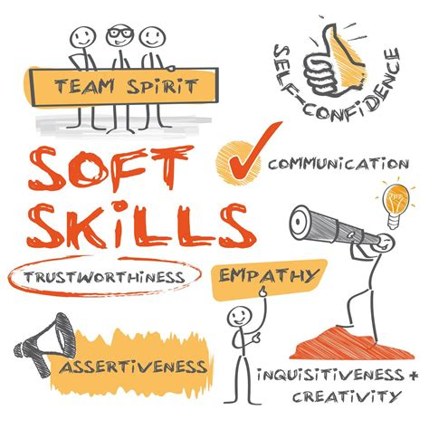

3. Employability

What does employability mean to you?
_____________________________________________________________________________

Watch a video to see what experts think employability means and discuss the questions.

Are their thoughts similar to yours? To what extent do you agree with their views?
_____________________________________________________________________________

How can we develop employability skills while still at school / university?
_____________________________________________________________________________

4. Prove your skills

Recruiters look for hard evidence that candidates have the skills their vacancy requires.
An instructive exercise is to list your skills together with examples of when you applied them.

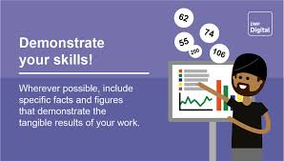

Typical skills are:
problem-solving written communication verbal communication adaptability
computer project management organisation teamwork
interpersonal decision making conflict resolution public speaking
leadership planning & organizing role modeling dedication

And typical qualities include:
practical evaluative meticulous creative
logical open to new experiences analytical adaptable

What skills and qualities from above do you think you have?
Choose one, and find instances in your personal experience, or your training to prove it. (use the list of action verbs)

Here is a list of action verbs to describe skills and accomplishments under the professional experience heading. Use them to describe any skills or accomplishments you want to highlight.

achieved
constructed
expanded
led
sampled
adapted
consulted
experimented
maintained
scheduled
administered
contacted
explored
managed
selected
advertised
contributed
expressed
marketed
serviced
advised
controlled
facilitated
managed
set up
aided
co-operated
explored
modelled
simplified
analysed
co-ordinated
focused
modified
sold
applied
created
forecasted
negotiated
solved
approved
debugged
found
operated
sought
assembled
decided
graded
outlined
specialised
assessed
defined
guided
overhauled
spoke
assisted
delegated
handled
participated (in)
streamlined
authorised
delivered
harmonised
performed
structured
bought
demonstrated
headed
pinpointed
summarised
budgeted
described
hired
planned
supervised
built
designed
developed
hosted
prepared/ studied
calculated
diagnosed
identified
presented
supplied
classified
directed
implemented
produced
supported
collaborated
displayed
improved
promoted
surveyed
collected
distributed
increased
purchased
taught
combines
drafted
informed
reduced
tested
communicated
drew
initiated
reorganised
trained
compared
edited
inspected
researched
translated
compiled
ensured
installed
resolved
treated
computed
established
integrated
restored
troubleshot
concentrated
evaluated
investigated
revamped
updated
conducted
examined
launched
reviewed
wrote

Class 6 - Skills (2)

1. Warm-up

Match the words from box A with the words from box B to make common phrases. Then, match them with their meanings.

BOX A | BOX B
draw  commit oneself  extracurricular  experience something  grasp  take | action  activities  an opportunity  conclusions  first-hand  to the task

Meanings:

decide what to believe about something after you have considered the facts: _________________

dedicate or devote oneself to something: _____________________________

take advantage of something when it happens: _____________________________

experience in a direct way by doing something yourself: _____________________________

things that you do at school or college that are not part of your course: _____________________

do something to achieve an aim or deal with a problem: _____________________________

2. Video “Tony Walker, deputy MD at Toyota”

Discuss the questions in pairs

What skills will you gain from your degree?
____________________________________________________________________________

What advice would you give to students in your course about their future employment?
____________________________________________________________________________

What are the most important skills people look for in an employee?
____________________________________________________________________________

What is your career plan once you finish university?
____________________________________________________________________________

Watch a video and note down how the speaker answers the four questions above.

What skills did you gain from your degree?
____________________________________________________________________________
____________________________________________________________________________

What advice would you give to students about their future employment?
____________________________________________________________________________
____________________________________________________________________________

What are the most important skills people look for in an employee?
____________________________________________________________________________
____________________________________________________________________________

What was your career plan once you finished university?
____________________________________________________________________________
____________________________________________________________________________

3. Motivation

Discuss whether you agree with the statement.

“Don’t work for the money, work to do a good job!”

Complete the quotes with the words motivate, motivating, motivated or motivation.

“If you must have _________________________, think of your paycheck on Friday.”
Noel Coward, English playwright

“I tend to be... they say ‘workaholic,’ which I just find to be ‘_________________________’.’”
Sarah Hay, American actress and ballerina

“People want to be part of something that's bigger than themselves. It's ____________________,. It helps all of us to work harder.”
Paul Jacobs, American businessman

“The best way to _________________________, me is to tell me I can't do something.”
Jimmy Graham, American football player

Discuss the quotes and say if you agree or disagree with them.

Read the sentences and complete the tasks below

a) It’s motivating to have an interesting and creative job.
b) If people are happy with their salaries, they are more motivated to do a good job.
c) I’m very motivated when I work in a team of people I like.
d) I think it’s important that you can develop in your company and that it provides a lot of promotion opportunities.
e) Offering employees cool perks such as a gym membership is a great idea to motivate them.

Tasks
1) Find two synonyms of ‘give’: _________________________________________________
2) Find a noun that means a move to a more important job or position in a company:
________________
3) Find a noun that means an additional payment or advantage that you get in your job: _________________

Guess three synonyms of the word ‘perk’. The letters should help you.

a) b o __ __us
b) ex __ __ a
c) b __ __ __ __ i t

Video : “Cool perks”

You’re going to watch a video in which employees are talking about ‘cool perks’ their companies offer. Look at the list below and mark four which you think the employees will mention.

• private healthcare
• happy hours
• car wash service
• language classes
• travel discounts
• free food
• company car
• parental leave
• company kindergarten
• sports tournaments

Watch the video and check your answers

Watch the video again and match the benefits to the companies: AOL, Adobe or Yahoo.
a) meditation room _____________________________________________________________
b) yoga classes ________________________________________________________________
c) fitness centre or classes _______________________________________________________
d) massage ___________________________________________________________________
e) lip sync battles ______________________________________________________________

Read the sentences and match the words and phrases in bold to the meanings below.

a) The company offers a lot of perks that are a magnet for millennials.
b) I’m jealous of his amazing life and all the things he can do.
c) They provide many sweet extras that their employees just love!
d) It’s one of the perk-packed companies that everyone wants to work at.
e) I think everyone will say yes to such a great offer.

Meanings:
1) having a lot of perks ___________________________
2) unhappy because someone has something that you would like _________________________
3) awesome ___________________________
4) agree to something or think that something is great ___________________________
5) something or someone that attracts many people or things ___________________________

Discuss the questions

• What motivates you at work? Are you motivated by perks?
• Which of the benefits that were mentioned in the video would you say yes to?
• What sweet extras are a magnet for people looking for a job now?
• Are you jealous of any bonuses that your friends or family get from their employers?
• Which benefits are useless in your opinion?

Class 7 - Written test

Class 8 - The job interview (1)

1. Warm-up : Audio interview

Choose the best answer for each question below:

1. How long has Kate been working for KP Lewis?
a. 3 years b. 4 years c. 8 years

2. How long has she been working in the accounting department?
a. 3 months b. 4 months c. 8 months

3. Why is she leaving her job?
a. she is not well-paid b. her skills are under-used c. Her boss is horrible

4. Is travelling a problem for her?
a. yes b. no c. maybe

5. Why was she successful as a sales representative for a language school?
a. the school increased its profit b. it sold more books c. more people registered

6. What are her short-term goals for the future?
a. buy a house b. develop her skill set c. become a manager

7. What are her long-term goals?
a. move to a senior position b. start her own business c. work for a school

8. What is her greatest weakness?
a. perfectionism (working too hard) b. time management c. shyness

9. How well does she work under pressure?
a. she stresses a lot b. she is okay c. she does better under pressure

2. Reading

Look at the list. Do you think these are good or bad things to say in an interview?
Put ‘G’ (Good) or ‘B’ (Bad) next to each sentence.
1. I’m looking for new challenges.
2. I’m really nervous.
3. How much will I earn?
4. In the short-term I want to develop my sales skills and gain more experience in selling.
5. My weakness is that I work too hard.
6. I really need this job!
7. I work quite well under pressure. I find it very motivating.
8. My current boss is horrible.
9. No, I don’t have any questions for you.
10. I love the idea of free snacks on Fridays!

Complete the text below with statements from above.

Here are 7 things you should never say in a job interview:

1. If you don’t know your potential salary, you shouldn’t ask about it too early in the interview. If you do this, the interviewer will think you are only interested in money and nothing else. Employers want people who are a good match for the position that they are offering. Salary negotiations should wait till the end of the interview.
____________________________________________________________________________________
____________________________________________________________________________________

2. Companies do not want to hire someone who doesn’t have any confidence. So, it’s not always good to be honest. If you are nervous, you should try not to show it.
____________________________________________________________________________________
____________________________________________________________________________________

3. If the interviewer asks about your weaknesses, you should not reply with a standard response that sounds like a hidden strength. Experienced interviewers know this trick. Instead, tell the employer about a real weakness, but a weakness that isn’t so important for the job.
____________________________________________________________________________________
____________________________________________________________________________________

4. Don’t mention how much you like some of the company’s benefits, such as free snacks. The interviewer will think that you do not care about the success of the company.
____________________________________________________________________________________
____________________________________________________________________________________

5. Try not to show that you are desperate for the job. Desperation is a sign of weakness.
____________________________________________________________________________________
____________________________________________________________________________________

6. Never criticize a former boss or company. It’s not classy, and it will make you sound negative.
____________________________________________________________________________________
____________________________________________________________________________________

7. When the interviewer asks if you have any questions, don’t say "no." This makes you look unprepared for the interview or not interested in the job or company.
____________________________________________________________________________________
____________________________________________________________________________________

Discussion

Do you agree with the advice in the article?

3. How you really sound in job interviews

Watch the video, then complete the column “What they hear” and give advice.

Job interviews are all about making the right first impression. Put things the wrong way, and they may hear something you never intended to say.

 | What you say | What they hear
The first impression | Hi, I'm really excited to meet you. I saw on your daughter's blog that she has a gluten allergy, so I got these gluten-free cookies, I hope she likes them. | ____________________________________________  ____________________________________________  ____________________________________________
 | Oh, I'm sorry, I didn't bring any copies of my résumé with me. | ____________________________________________  ____________________________________________  ____________________________________________
 | Sorry I'm late due to traffic. | ____________________________________________  ____________________________________________  ____________________________________________

Advice
Do not ______________________________________________________________________________
____________________________________________________________________________________
instead, ______________________________________________________________________________
_____________________________________________________________________________________

What happened with your previous job? | They really didn't know how to take advantage of my skills. | ____________________________________________  ____________________________________________  ____________________________________________
 | My old boss Tim, do you know him? I love Tim to death. He didn't really get social media, but god I love that guy. | ____________________________________________  ____________________________________________  ____________________________________________

Advice
Do not ______________________________________________________________________________
____________________________________________________________________________________
instead, ______________________________________________________________________________
_____________________________________________________________________________________

What is your biggest flaw? | My biggest flaw is that I'm a perfectionist. | ____________________________________________  ____________________________________________  ____________________________________________
 | Well, I'm not good at public speaking, or delegating, or working in Excel. | ____________________________________________  ____________________________________________  ____________________________________________
 | I really don't have any flaws. | ____________________________________________  ____________________________________________  ____________________________________________

Advice
Do not ______________________________________________________________________________
____________________________________________________________________________________
instead, ______________________________________________________________________________
_____________________________________________________________________________________

Where will you be in five years? | Where will I be in five years? In your job! Just kidding... | ____________________________________________  ____________________________________________  ____________________________________________
 | I wanna invent the next Uber. | ____________________________________________  ____________________________________________  ____________________________________________
 | I mean, honestly, I would just like really love to get away from the clients and this like business setting... Maybe I'll move to Europe or Africa or Asia, or open up an Etsy store... something like that. | ____________________________________________  ____________________________________________  ____________________________________________

Advice
Do not ______________________________________________________________________________
____________________________________________________________________________________
instead, ______________________________________________________________________________
_____________________________________________________________________________________

Do you have any questions for me? | What kind of medical insurance do you provide? | ____________________________________________  ____________________________________________  ____________________________________________
 | What's your vacation policy like? | ____________________________________________  ____________________________________________  ____________________________________________
 | Do you think I'll get an office? | ____________________________________________  ____________________________________________  ____________________________________________

Advice
Do not ______________________________________________________________________________
____________________________________________________________________________________
instead, ______________________________________________________________________________
_____________________________________________________________________________________

Anything you'd like to add? | Sorry, I'm expecting a call. | ____________________________________________  ____________________________________________  ____________________________________________

Advice
Do not ______________________________________________________________________________
____________________________________________________________________________________
instead, ______________________________________________________________________________
_____________________________________________________________________________________

Why should you get the job? | I really want this job. | ____________________________________________  ____________________________________________  ____________________________________________
 | I'm a team player and I'm a people person. | ____________________________________________  ____________________________________________  ____________________________________________
 | I'm not really looking right now, but I would consider taking it if the price was right. | ____________________________________________  ____________________________________________  ____________________________________________

Advice
Do not ______________________________________________________________________________
____________________________________________________________________________________
instead, ______________________________________________________________________________
_____________________________________________________________________________________

4. Questions YOU ask at the end of the interview

What is the point of asking questions to the interviewer(s)?
____________________________________________________________________________________
____________________________________________________________________________________

There are 3 types of questions that you could ask. Guess what they are about.

Type 1: (tip: show you’re interested in working here!)
____________________________________________________________________________________

Type 2: (tip: demonstrate interest about your future role)
____________________________________________________________________________________

Type 3: (tip: dare to be bold!)
____________________________________________________________________________________

Now brainstorm example questions for each category.

Type 1:
____________________________________________________________________________________
____________________________________________________________________________________
____________________________________________________________________________________
____________________________________________________________________________________
____________________________________________________________________________________

Type 2:
_________________________________________________________________________________________________________________________________________________________________________
____________________________________________________________________________________
____________________________________________________________________________________
____________________________________________________________________________________

Type 3:
____________________________________________________________________________________
____________________________________________________________________________________
____________________________________________________________________________________
____________________________________________________________________________________
____________________________________________________________________________________

Do you think there are questions a candidate should NOT ask?
____________________________________________________________________________________
____________________________________________________________________________________
____________________________________________________________________________________
____________________________________________________________________________________
____________________________________________________________________________________

Class 9 - Job interviews (2)

1. Fifty standard interview questions

Behavioral questioning is based on the idea that the best way to predict someone’s future performance is by looking at their past performance in a similar situation. This type of questioning is tough but it is made way easier when following the STAR method.
Can you recognize which of these questions are behavioral questions ? Circle them.

1. Tell me about yourself.
2. Tell me about your experience.
3. What is your most important accomplishment to date?
4. How would you describe your ideal job?
5. Why did you choose this career?
6. When did you decide on this career?
7. What goals do you have in your career?
8. How do you plan to achieve these goals?
9. How do you personally define success?
10. Describe a situation in which you were successful.
11. What do you think it takes to be successful in this career?
12. What accomplishments have given you the most satisfaction in your life?
13. If you had to live your life over again, what one thing would you change?
14. Would you rather work with information or with people?
15. Are you a team player?
16. What motivates you?
17. Why should I hire you?
18. Are you a goal-oriented person?
19. Tell me about some of your recent goals and what you did to achieve them.
20. What are your short-term goals?
21. What is your long-range objective?
22. What do you see yourself doing five years from now?
23. Where do you want to be ten years from now?
24. Do you handle conflict well?
25. Have you ever had a conflict with a boss or professor? How did you resolve it?
26. What major problem have you had to deal with recently?
27. Do you handle pressure well?
28. What is your greatest strength?
29. What is your greatest weakness?
30. If I were to ask one of your professors (or a boss) to describe you, what would he say?
31. Why did you choose to attend your college?
32. What changes would you make at your college?
33. How has your education prepared you for your career?
34. What were your favorite classes? Why?
35. Do you enjoy doing independent research?
36. Who were your favorite professors? Why?
37. Why are your exam results not better?
38. Do you have any plans for further education?
39. How much training do you think you’ll need to become a productive employee?
40. What qualities do you feel a successful manager should have?
41. Why do you want to work in this firm / company?
42. What do you know about our company?
43. Why are you interested in our company?
44. Do you have any location preferences?
45. How familiar are you with the community that we’re located in?
46. Are you willing to relocate? In the future?
47. Are you willing to travel? How much?
48. Is money important to you?
49. How much money do you need to make to be happy?
50. What kind of salary are you looking for?

2. How to prepare for behavioural questions: The STAR Method

Behavioural questioning is based on the idea that the best way to predict someone’s future performance is by looking at their past performance in a similar situation. This type of questioning is tough but it is made way easier when following the STAR method.

The STAR Method
The STAR method is a framework for organising your response in order to provide a complete answer without rambling.
• S – Situation: Give a situation you were involved in that resulted in a positive outcome.
• T – Task: State the tasks involved in that situation. At times, the 'Situation' and the 'Task' can be very similar or the same.
• A – Action: Discuss the various actions you took to complete the task.
• R – Result: End with the results of your actions.

Build Your Stories

Turning your experiences into STAR stories will give you a variety of succinct answers to draw upon.
When you’re preparing for an interview, find the key skills that are required in the job description like strong leadership or organisational skills. This will help you figure out the themes of potential questions such as explaining a time when you took a leadership role on a project.
Now that you know generally what the questions may be, identify specific experiences about these skills from your past that you could use. Turning these experiences into stories in the STAR framework will allow you to have a wide selection of succinct answers at your disposal.
If you spend time developing stories for a variety of skills or potential questions, it is much easier to find answers that can be slightly modified to respond to any behavioural question.

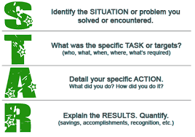

A simple example:
Interviewer: "Tell me about a time when you recognized a problem and took steps to address it."
Your brilliant answer:
Situation: "During my internship last summer, I was responsible for managing various events."
Task: "I noticed that attendance at these events had dropped by 30% over the past 3 years and wanted to do something to improve these numbers."
Action: "I designed a new promotional packet to go out to the local community businesses. I also included a rating sheet to collect feedback on our events and organised internal round table discussions to raise awareness of the issue with our group members."
Result: "We utilised some of the wonderful ideas we received from the community, made our internal structure more transparent, and raised attendance by 18% the first year."

Video explaining the STAR method

Now choose a behavioural question and prepare an answer, using the STAR method:
(See the “List of Interview Questions” and “List of Action Verbs”.)

Question: __________________________________________________________________________
Your brilliant answer:
Situation:
____________________________________________________________________________________
____________________________________________________________________________________
Task:
____________________________________________________________________________________
____________________________________________________________________________________
Action:
____________________________________________________________________________________
____________________________________________________________________________________
Result:
____________________________________________________________________________________
____________________________________________________________________________________

3. Pair-work: Simulating a job interview

Find a partner. In turn, you will play the role of the recruiter and that of the candidate. As the recruiter, you will have to prepare some questions and, as the candidate, you will have to be prepared to answer your partner’s questions while controlling your body language.
(See the “List of Interview Questions” and “List of Action Verbs”.)

Class 10 - The future of job search

1. Look at different ways to find a job and decide how relevant they are today.
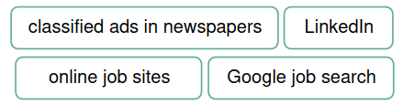

2. Complete each idea and explain your position.

a) If I were to give advice to somebody who’d like to land a job ª in my sphere,…
b) To me, going above and beyond in finding my next gig ^{b} would mean…
c) Being on a job hunt ^{c} today means…
d) The use of AI by HR managers to sift through applications ^{d} can lead to...
e) While job hopping ^{e} might seem a bit of a negative phenomenon to some, it can also be a sign that people…
f) Nowadays, being a good fit for a job ^{f} often goes beyond just technical skills, with employers placing greater emphasis on…
g) In my professional sphere, what you might need to do in order to get your foot in the door ^{g} is…
h) With HR managers using AI to analyse applications, the best way to jazz up your résumé ^{h} would be…

Make sure you understand the phrases in italics:
___________________________________ go through applications
___________________________________ make a résumé more interesting
___________________________________ get a job
___________________________________ someone who meets all the job requirements
___________________________________ get a short-term job
___________________________________ changing jobs frequently
___________________________________ on the lookout for a new job
___________________________________ enter an organization at a low level

3. Read the opinions about the use of AI in the recruitment process and decide who might have expressed them. Then, say which opinion resonates with you most and why.

a) I can't help but be excited about how AI is transforming the hiring process. Hands down, it’s a game changer on so many levels. Apart from increased efficiency, AI-powered tools can also help eliminate bias in the hiring process. We all know how our own biases can influence our decision-making, don’t we? I mean, think back to ten years ago when we had to sift through stacks of résumés and conduct interviews that could drag on for weeks. Not to mention that we had to rely more on gut instincts and face-to-face interactions, which could be hit or miss, really.
_____________________________________________________________________________

b) I couldn’t be more frustrated with all these AI gimmicks in the hiring process! I remember back in the day, say ten years ago, things were so much simpler. While on a job hunt, you could just submit your résumé, maybe go in for an interview, and then actually have a good chance of landing the job. But with all this AI stuff, it’s like the system doesn’t even care about my qualifications or my experience – all it cares about is some algorithmic match between my résumé and the job description. How can a machine decide whether I’m a good fit for the job? It’s not fair, to say the least!
_____________________________________________________________________________

4. You’re going to watch a video about a new recruitment app which some people call ‘The Tinder for jobs’. Why do you think it is called this?
_____________________________________________________________________________
_____________________________________________________________________________

5. Watch the first part of the video (to 01:29) and answer the questions.

a) What was Sam doing after COVID hit?
_____________________________________________________________________________

b) What inspired Sam to create a recruitment app?
_____________________________________________________________________________
_____________________________________________________________________________

c) What does a job seeker need to do if they want to use getahead to find their next gig?
_____________________________________________________________________________
_____________________________________________________________________________

6. Complete the notes about the getahead app based on what you have learned about it from the first part of the video. Watch the second part of the video (from 01:30) and check your answers.

a) Apart from creating your account, you can also use getahead to DM the companies and _____________________________________________________________________________

b) The app has been popular with big companies and _________________________________

c) Industries that are gaining the most traction include hospitality, ________________________

d) What makes getahead different from other recruitment apps is user experience and _________

e) The average industry hiring time is 24 days, but getahead hopes to reduce it to ____________

f) The way the popularity of the app has been growing so far is purely organic but… the marketing campaign will start next week. _____________________________________________________
7. Discuss the questions.

How helpful might the getahead app be in landing a good job in your field?
_____________________________________________________________________________
_____________________________________________________________________________

Would you be interested in having a go at finding your next job using this app? Why/Why not?
_____________________________________________________________________________
_____________________________________________________________________________

What are some pros and cons of using this app while on a job hunt? What are some pros and cons of using this app for employers?
_____________________________________________________________________________
_____________________________________________________________________________

How might apps like getahead change the face of recruitment in the near future?
_____________________________________________________________________________
_____________________________________________________________________________

How can an employer measure the success of the getahead app and its impact on the hiring process?
_____________________________________________________________________________
_____________________________________________________________________________

Do you think your company would consider using the getahead app?
_____________________________________________________________________________
_____________________________________________________________________________

Do you think that recruitment apps like getahead will eventually replace traditional hiring methods?
_____________________________________________________________________________
_____________________________________________________________________________

Explore the site of the getahead app https://getahead.com.au/

Does the site provide more in-depth information about the app than the video? If yes, what else did you learn about this app?
_____________________________________________________________________________

What do you think employers and employees base their decisions on when swiping left or right?
_____________________________________________________________________________

If you were to create your profile on this app, how could you make sure it stands out?
_____________________________________________________________________________

8. Paraphrase the descriptions of other recruitment apps using the phrases in brackets. Make any other necessary changes.

a) Reed enables you to be the first to know about new job ads and allows you to look for jobs throughout the day, wherever you are, increasing your chances of being hired.
(be on a job hunt, sift through, land a job)
_____________________________________________________________________________
_____________________________________________________________________________

b) With Glassdoor, you can use the ‘Know Your Worth’ tool to adjust your salary expectations based on your experience, achievements and qualifications to end up with a job at your dream company. (a good fit for a job, get your foot in the door)
_____________________________________________________________________________
_____________________________________________________________________________

c) With CareerBuilder, you can apply for jobs without creating a profile or signing in, which allows you to freely look through job listings, but you can also use it to create your CV quickly and easily and showcase it for potential employers. (find your next gig, sift through, jazz up)
_____________________________________________________________________________
_____________________________________________________________________________

d) Zoek uses AI-based technology and helps you find the most relevant vacancies that correspond to your skillset so you can finally stop changing jobs frequently.
(sift through, a good fit for a job, job hopping)
_____________________________________________________________________________
_____________________________________________________________________________

e) Snagajob is a go-to app for you if you’re looking for a part-time or temporary job, or if you’re a student who needs flexibility around their schedule. (on a job hunt, job hopping)
_____________________________________________________________________________
_____________________________________________________________________________

9. Study the spidergram and discuss the questions.
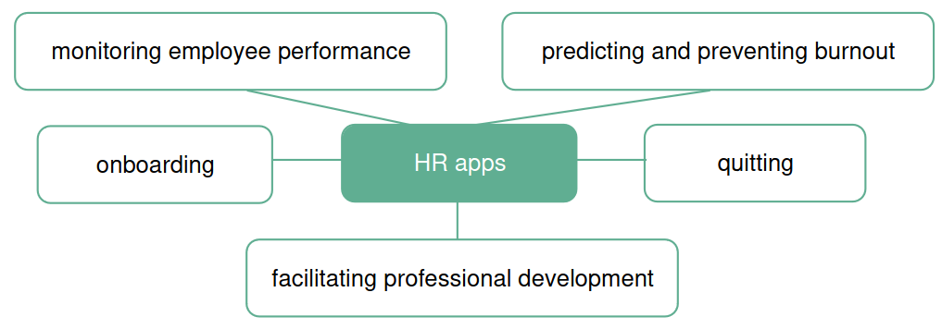

Do you know any apps that help with the HR processes mentioned in the spidergram? If not, what features might they include to make a difference in each of these processes?
_____________________________________________________________________________
_____________________________________________________________________________

Which of these apps, in your opinion, are already supported by AI/will soon be
supported by AI/will never be supported by AI? Explain your position.
_____________________________________________________________________________
_____________________________________________________________________________

Complete the lines of a dialogue using the phrases from the lesson (initial letters are provided), then put the lines in the right order.

A 1: Hello! Have you heard of JobAware? It's a recruitment app that can help you l_________ a great j___ in no time.

A 2: JobAware can definitely help with that too. Our app allows you to easily create a professional-looking résumé that will grab the attention of hiring managers as they s_________ t_________ tons of applications.

A 3: That's great to hear. With JobAware, you can easily search for job opportunities and filter them based on your skills and experience. We can help you find positions where you'll be a g_________ f_________ for the j_________.

A 4: Absolutely. And even if you're not a perfect match for a job, we can help you g_________ your f_________ in the d_________ by connecting you with hiring managers and providing you with valuable interview tips.

B 1: Oh, interesting! I'm actually on a j_________ h_________ right now, so I'm definitely on the lookout for effective ways to f_________ my n_________ g_________.

B 2: That sounds perfect. I don't want to end up j_________ h_________ again, so finding the right position is really important to me.

B 3: That's great to know. I've been trying to j_________ u_________ my r_________ but it can be tough to stand out among all the other applicants.

B 4: That sounds like a really comprehensive solution for job seekers. I'm definitely interested in learning more about JobAware.

Correct order : ________________________________________________________________

ANNEXES

Writing a CV

Look at the CV on the next page and discuss the questions.

• Is it a chronological, functional or combination CV?

• Which pieces of advice did the writer use?
- You have to include your phone number in the contact information section.
- The résumé objective should say something about your skills.
- You should write between three and five bullet points under each job title.
- You should include both hard and soft skills.
- You should write where your school/university is.

• Which of the skills in the CV are soft and which are hard? Why do you think so?

• Would you add any of those skills to your CV? Why/Why not?

• What do you like or dislike about the CV?

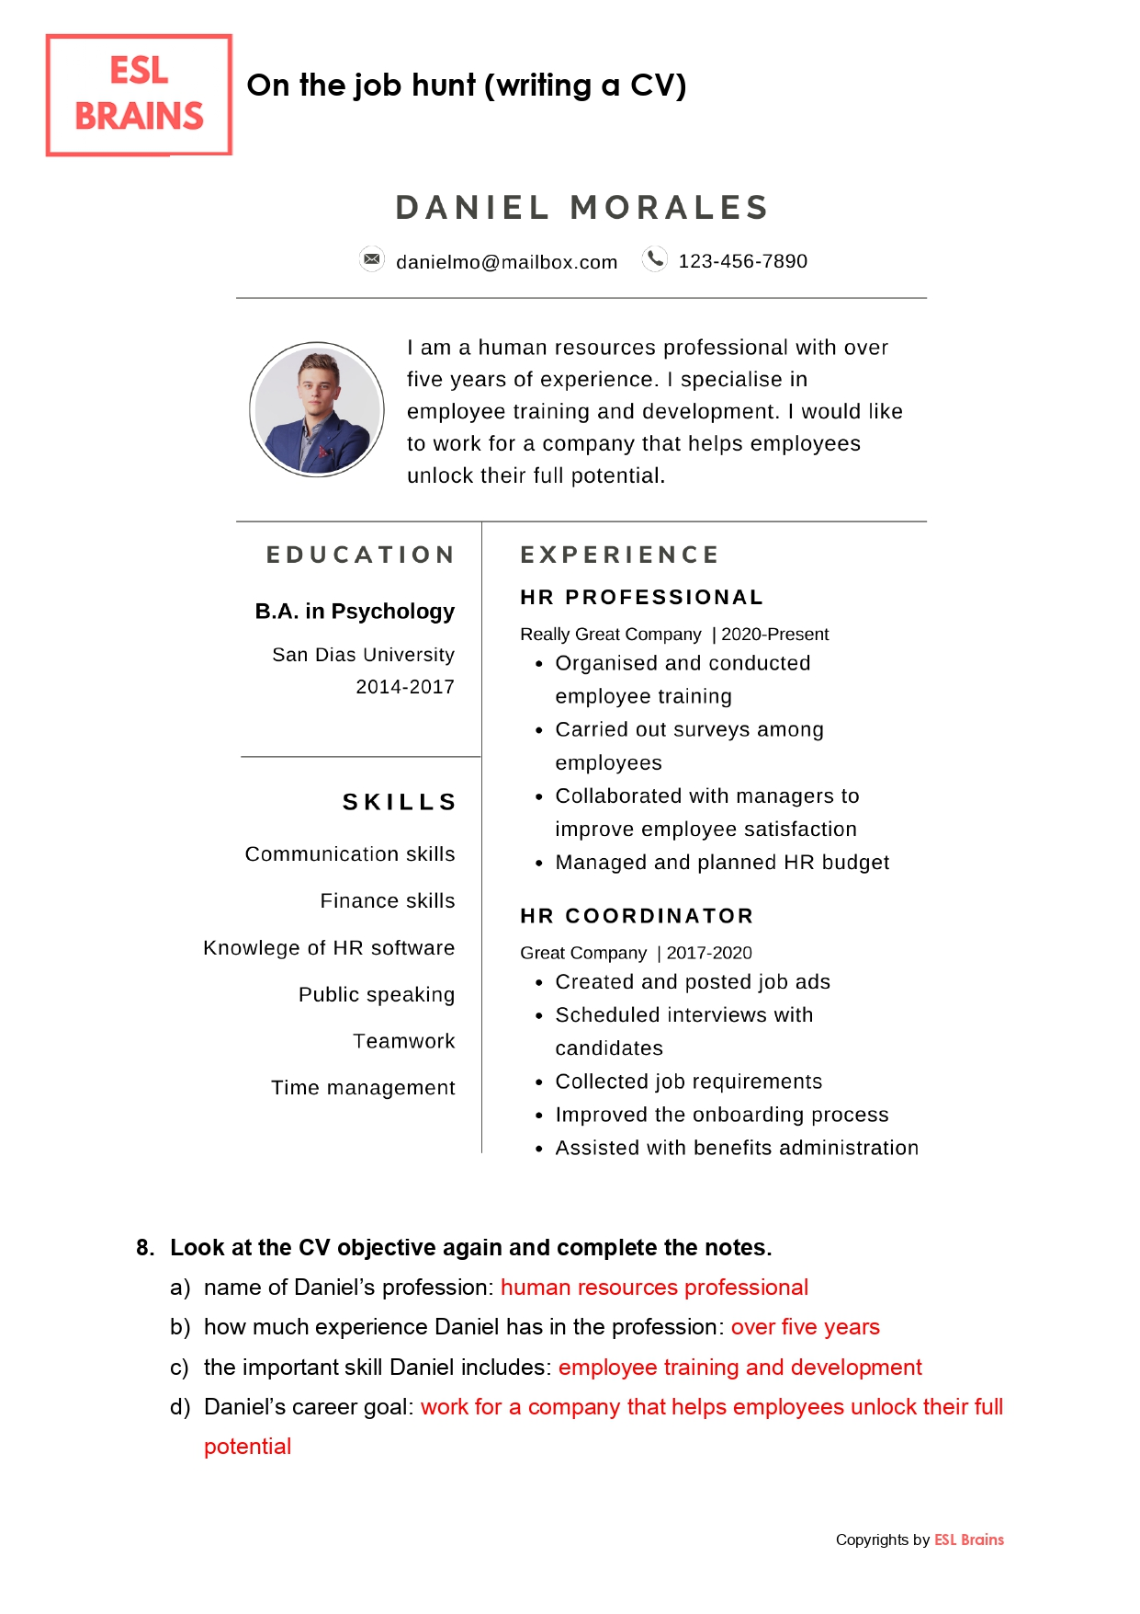

Look at the CV objective again and complete the notes.

a) name of Daniel’s profession: ____________________________________________________
b) how much experience Daniel has in the profession: __________________________________
c) the important skill Daniel includes: _______________________________________________
d) Daniel’s career goal: __________________________________________________________

Objective or Career Aim

Your CV should include an aim / objective. This is an excellent way to grasp attention and to give the reader some focus to the sort of career you want to enter.

• avoid overgeneralized statements, such as “A position allowing me to utilise my knowledge and expertise in different areas.”
• avoid statements that focus only on what a company can do for you: “A position where I gain experience in working on IT problems.”
Prefer: “To find employment as a junior scientist or technician to launch my scientific career.”
or “To develop my skills/acquire hands-on experience in the field of……through an internship.”

→ Write your Aim / Objective
_____________________________________________________________________________
_____________________________________________________________________________

Exercise

Chronological CV “Jane Moore” - Find the equivalents for these words

à la recherche de: __________________________________
un poste d'ingénieur: __________________________________
un stage: __________________________________
compétences mises au service de...: __________________________________
Licence en sciences : __________________________________
obtenir son diplôme avec les félicitations du jury: __________________________________
résoudre (des problèmes): __________________________________
effectuer (une tâche): __________________________________
recueillir (des données): __________________________________
mettre en place: __________________________________
faire office de: __________________________________

Jane Moore
1414 West Wilson, Seattle, WA 98105, 206-555-1212
jmoore@anymail.com
http://www.linkedin.com/janemoore

OBJECTIVE
Seeking an entry-level software engineering position in which my internship experience in programming, Unix/Linux environments, and cloud computing, and my creativity and strong problem-solving, interpersonal, and communication skills can be effectively utilized to help assist users and increase profits.

EDUCATION

Stanford University, Stanford, California, 2010–2012
Master of Science in Computer Science-Mobile and Internet Computing Track

Stanford University, Stanford, California, 2006–2010
Bachelor of Science in Computer Science
Graduated cum laude
President of Campus Leadership Society

WORK AND INTERNSHIP EXPERIENCE

September 2011 – Current : Genius
• Work at Genius Bar to troubleshoot customers’ hardware and software problems
• Named “Employee of the Month” for December 2011

Amazon - Seattle, Washington
June 2011–August 2011 - Software Engineering Internship
• Performed code-level troubleshooting of traffic anomalies
• Helped engineers build new automation infrastructure
• Collected and analyzed statistical data

COMMUNITY INVOLVEMENT

Tech Corps, Seattle, Washington, Summer 2011/Summer 2012
• Taught programming to young people ages eight to 18
• Set up technology infrastructure at schools and community centers

Google Student Ambassador, Stanford University, 2010
• Acted as campus contact for Google teams
• Planned and hosted fun and informative tech-related events on campus
• Educated fellow students about Google’s culture and products

COMPUTER SKILLS
C, C++, Java, Python, Unix/Linux, Windows

Functional or skill-based CV “Leo N. Bize” - Find the equivalents for these words

poste à temps plein : __________________________________
à dominante … : __________________________________
moyenne des notes obtenues [acronyme] : __________________________________
interface de programmation [acronyme]: __________________________________
étudier, concevoir et mettre en œuvre: __________________________________
récolter des données sur (un projet) : __________________________________
mettre à niveau : __________________________________
concours : __________________________________

Leo N. Bize
e:mail: leo.n.bize@rose-hulman.edu - http://www.rose-hulman.edu/~bizeln

School Address: Permanent Address:
5500 Wabash Ave, Box 19887, 2160 Greentree Road,
Terre Haute, IN 47803 Pittsburgh, PA 15212
(812)877-1511 (412)256-5688

Objective Full time position in the field of computer science with emphasis on both
hardware and software

Education B. S. Computer Science, May 2005 GPA 3.33/4.0
Rose-Hulman Institute of Technology, Terre Haute, IN

Skills Computers
• C, Visual/Turbo C++, Maple, Matlab, Glut, OpenGL, Ada, BASIC, LISP, CadKey, AutoCAD, Pro/Engineer, and LogicWorks
• Wrote programs now in use at Inland Steel Bar Company for metallurgical calculations

Robotics
• Custom circuit board fabrication, computer interfacing
• Robotic gantry cranes, remote exploration vehicles, all home-built
• Voice and screen menu driven control, robot control program APIs
• 2-D ultrasonic area mapping and robotic vehicle location through wireless data links
• 3-D computer simulation/virtual reality with a Nintendo Power Glove

Experience CYBO Robots, Indianapolis, IN
Software Development Intern Summer, 2014
• Researched, designed, and implemented a new robot move database which was "generic, expandable, and flexible"
• Used MAPLE for circular interpolation, representation, and translation prototyping
• Code currently being used in new controller to be shipped to Caterpillar Oct. 2015

Software Testing Intern Summer, 2013
• Designed, executed, and documented a testing scheme for a robotic welding platform
• Wrote robotic control code, debugged electrical/electronic systems
• Test results are now begin used to upgrade and further develop current systems

Field Robotics Center, Carnegie-Mellon University, Pittsburgh, PA
REU Intern Summer, 2012
• Assisted in the development of a prototype robot, Houdini
• Developed and tested the mechanical systems and hydraulic assemblies

Honors
• Kauffman Foundation Entrepreneurial Internship Program, Summer 2003
• First Place, American Society of Computing Machinery Programming Contest

Combination CV “BLIMEY James” - Find the equivalents for these words

diplôme de … : __________________________________
actuellement : __________________________________
obtention du diplôme : __________________________________
circuit imprimé ARM : __________________________________
excellente connaissance de ...: __________________________________
en langage courant : __________________________________
mener des recherches : __________________________________
notes de synthèse : __________________________________
groupes de discussion : __________________________________
enquêtes : __________________________________
acquérir de l'expérience à travers … : __________________________________
former les nouveaux employés : __________________________________
sites institutionnels : __________________________________
fournir un accompagnement de niveau II : __________________________________
tenir à jour un inventaire : __________________________________
assurer un service client efficace et courtois: __________________________________
engagement, enthousiasme : _________________________________

BLIMEY James
123 Main St., Victoria, BC V8W 3P6 • Email: james.blimey@uvic.ca • Phone: (250) 555-5555

EDUCATION
Computer Science Major / Business Option (Co-op) University of Victoria.
Currently in 3rd year; GPA : B+; seeking Work Term 3. Graduation anticipated for 2014.
Trout Lake High School, Trout Lake, BC. Graduated in 2010.

TECHNICAL SKILLS
• Programming experience with C, C#.NET, Python and Java, as well as some database experience using MySQL and Postgres.
• Design and Animation: AutoCAD, 3D Studio Max
• JavaScript, HTML and CSS: created a variety of websites, commercial and personal
• Assembly Language: Programmed an ARM board; coded a lunar landing game
• Currently learning VB.net and C#
• Operating Systems: Linux, Unix, OS 10, Windows XP
• Troubleshooting and configuration experience in both Windows and MacOS based systems
• Strong understanding of various data structures and algorithms
• Application experience in a variety of office suites, multimedia and graphics programs, network utilities
• Able to explain high-level technical concepts and ideas in plain language to end users/clients

BUSINESS SKILLS
Conducted marketing and statistical research, writing up results in concise briefing notes;
organized and lead both focus groups and surveys.
Gained project management experience during co-op work term and through university software engineering courses

WORK EXPERIENCE
Internet Multimedia Developer (Co-op Work Term #2) Fall 2011 - Dewey, Cheatem and Howe Corp.
• Designed social media solutions for marketing department
• Integrated new and upcoming media technologies into existing infrastructure
• Worked with small team to plan for upgraded internal streaming infrastructure
• Trained new employees in a rapidly expanding team environment
• Collaborated with external customers and business partners to determine best practices for user interface design for corporate websites.

Computer Help Desk Consultant (Co-op Work Term #1) Spring 2011 - University of Victoria
• Provided tier two support to University faculty, staff and students in their use of the campus network, dial-in services, applications, operating systems, and various hardware.
• Solved variety of user problems, including account set-up, password issues, software configuration.

Sales Associate/Computer Assistant Summers, 2009-2010 - Trout Lake Computers Ltd.
• Configured PCs for customers, installing software and attaching peripherals
• Maintained inventory of parts, sourcing and ordering additional inventory as required
• Provided friendly, effective customer service; skilled at solving programs and explaining technical concepts in plain language.

AWARDS
Paige Turner Memorial Scholarship for computer studies and citizenship, Trout Lake High School
Passport to Education Scholarship Award
Various soccer awards for “leadership, sportsmanship, and dedication to the game"

HOBBIES AND INTERESTS
Camping, hiking, cycling, skiing.
Playing piano and trombone.
REFERENCES
Available at interview.

Degree equivalents

You do not have a “Bachelor’s degree”, you have a French “Licence”, equivalent to a Bachelor’s degree. Here are the equivalents.

Age or  number of years | France | Great Britain | The United States
16 | Diplôme National du Brevet (DNB) | GCSE  (General Certificate of Secondary Education) | No equivalent
18 | Baccalauréat  Mention TB  Autre mention | A-Levels (mention main subjects)  With higher honours  With distinction | High School diploma  With highest honors  With distinction
 | DEUG (before 2004, no longer delivered) | French two-year university degree | Junior College Degree
After 3 years of university studies or 4 years in some British universities and in the USA | Licence  Mention AB  Mention B  Mention TB | Bsc (Bachelor’s degree of science) in + specialist subject  or BA (Bachelor of Arts)  2.2 (two-two)  2.1 (two-one)  first | Bsc (Bachelor’s degree of science) in + specialist subject  or BA (Bachelor of Arts)  Cum laude  Magna cum Laude  Summa Cum Laude
After 4 years of university studies or 5 in some British universities |  | Master’s degree  Msc (Master of science) | “graduate school”
5 years of university studies | Master | Master’s degree | Master’s degree
After a minimum of 8 years of university studies | Doctorat | Ph.D + in specialist subject  or Doctorate in + specialist subject | Ph.D + in specialist subject  or Doctorate in + specialist subject

Other useful equivalents
MIAGE | Computer methods applied to Business Management
Formation en alternance | Sandwich course, work-study course, course with in-company periods
D.U.T. / B.U.T.. | Technical degree or HND (Higher National Diploma)
IUT | University Institute of Technology / Polytechnic school
Ecole d’ingénieur | Engineering school
B.T.S. | Degree of Qualified Technician or HNC (Higher National Certificate)
Classes Préparatoires aux Grandes Ecoles (CPGE) | Preparation for the competitive entrance examination to French Advanced Engineering Schools
Diplôme de secouriste / secouriste du travail | First Aid Certificate / Occupational First Aid Certificate
GSON | Data Science Skills Certification (complementary to Master’s degree)

How to assess your level in foreign languages

1. Make sure you know what these words mean and practise pronunciation

fluent in - proficient in - bilingual - multilingual - native speaker - intermediate - advanced

2. Discuss the following issues

What are the various language skills commonly included in CVs?
What is the importance of each language skill in various professional contexts?

Do’s and Don’ts for CV writing

Don’t
- Write about yourself in the third person, for ex. He has worked to a consistent level...
- Attempt to be humorous.
- Leave gaps.
- Split an important point between two pages
- Overdo your hobbies.
- Use colourful paper or designs, fancy fonts, colours etc.

Do
- Read the details of the post carefully and tailor your CV to meet the requirements of the job
- Be brief and to the point : keeping your sentences short makes your CV sound punchy and concise.
- Focus on your strengths : stress the skills you have which are particularly relevant for the post ; if you have no employment experience, focus on your education
- Place temporary jobs not relevant to the position together, e g: 2012-2014: Various temporary jobs
- Include hobbies relevant to the job, such as those demonstrating teamwork and commitment
- Space = importance. Give more space to those parts of your CV that sell you better.
- Check spelling, punctuation (capitals !), grammar

Writing a cover letter

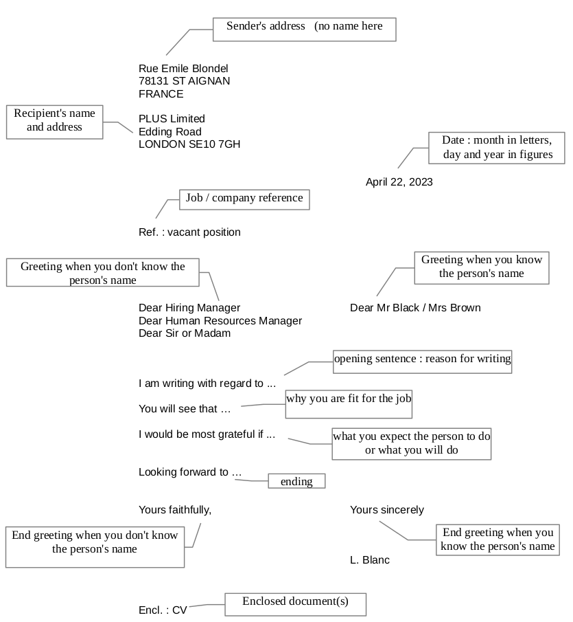
1. Layout

General guidelines

A cover letter should be short: one page maximum, no more than 4 paragraphs .
It must be typed and conform to the standards of English business correspondence .
Use spell-check (first select English as the language for the document) .
Mister, Mr, Ms and Miss must be followed by a last name (family name).
DO NOT translate your French letter .DO NOT include the city when you write the date.
DO NOT use contractions or slang (I'd, can't, guys, gonna, etc)

Structure

The use of the AIDA pattern (ATTENTION, INTEREST, DESIRE, ACTION) will result in a cover letter that is both pleasing to read and effective.
The first paragraph (A I )
Two or three sentences in length.
Start with an interest-creating sentence in which you appeal to the employer’s needs.
Be as specific as you can about the position desired.
Give information to show your specific interest in the company.

The second paragraph ( D )
Usually three to five sentences in length.
- Create desire. Give details of your background that will show the reader why he should consider you as a candidate.
- Emphasize a match between the skills which you possess and those required by the employer. Always say what you can do for the organisation, how you can contribute.
- Tell your story but keep it brief and to the point.
- At the end of this paragraph make a reference to your CV/resume.
The third paragraph (A )
Two to three sentences in length.
In your closing paragraph you ask for action. Tell the employer how to get in touch with you, and thank the person for taking time to give you consideration.

Useful language

Qualifiers

Do not hesitate to be specific when relating to your experience or knowledge. To do so, use a qualifier. Match adjectives and what they can describe.
Use... | To describe...
hands-on, strong, solid, excellent, wide, extensive, broad, varied, successful | experience
in-depth, detailed, thorough, first-hand, extensive | knowledge
outstanding, excellent, proven, strong | ability / background / skil
leading, pioneer, small-sized, medium-sized, top-ranking, large, major, fast-growing, reputation of excellence | a company
challenging, rewarding, responsible, entry-level, | a position
leading-edge, cutting-edge, latest, most advanced | a technology
innovative, highly organized, strongly / highly motivated, deeply committed, outgoing, enthusiastic, keen to join a team | personality
can meet deadlines, can deliver on time, good time management | respecting deadlines

Exercises:

a- Greetings See https://youtu.be/ITiPEQ2kL18

When you are writing to a woman but you don't know her name, use:
_____________________________________________________________________________
When you are writing to a man but you don't know his name, use:
_____________________________________________________________________________
When you know the job title of the person but not their gender or name, use:
_____________________________________________________________________________
When you don't know exactly who will read your letter, use:
_____________________________________________________________________________
If you begin with: Dear Ms / Mrs / Mr James, use the closing salutation: _____________________________________________________________________________
If you begin with: Dear Sir or Madam, use the closing salutation: _____________________________________________________________________________

b- Translate these sentences from a cover letter:

The first paragraph

Je souhaite postuler pour le poste de stagiaire publié dans…. J’obtiendrai mon Master en juin.
_____________________________________________________________________________
_____________________________________________________________________________
Je suis très intéressé par le poste de….
_____________________________________________________________________________
Professeur Watson m’a recommandé XL Computer pour un poste de stagiaire.
_____________________________________________________________________________

The second paragraph

Un stage chez [company] sera la meilleure occasion d’élargir mes connaissances dans le domaine de …
_____________________________________________________________________________
….d’acquérir savoir-faire et expérience pratique
_____________________________________________________________________________
…et de me familiariser avec les pratiques professionnelles à l’étranger.
_____________________________________________________________________________
Veuillez trouver ci-joint mon CV qui vous procurera une vue plus complète de ma formation/de mes compétences/aptitudes.
_____________________________________________________________________________

The third paragraph

Si vous désirez de plus amples renseignements, vous pouvez me contacter au…..
_____________________________________________________________________________
Je suis disponible pour un entretien à votre convenance.
_____________________________________________________________________________
Dans l’attente de votre réponse…
_____________________________________________________________________________
Je suis convaincu que ma formation universitaire et mon expérience seront utiles à votre entreprise.
_____________________________________________________________________________

c) Choose the best word(s) to complete each blank.
1. I'm writing ____________________ your advertisement in the Los Angeles Times.
in response to to respond at in respond to
2. I'm writing to ____________________ the possibility of employment with your company.
question about inquest about inquire about
3. I have a ____________________ deal of experience in web development.
lot large great
4. I'm a ____________________ motivated self-starter.
high highly heightly
5. I have been ____________________ for my ability to manage others.
noticed notified recognized
6. I would very much like to meet with you __________________ to discuss this position.
in person personal for a chat
7. I would very much like to meet with you to discuss this position _________________.
in detail in details in detailed
8. I will call you on Tuesday to arrange a ____________________ meeting.
eye-to-eye nose-to-nose face-to-face
9. My main area of ____________________ is ...
expert expertise experience
10. As the ____________________ CV/resume illustrates, ...
attached enclosed encapsulated

d) Fill in the blanks in the cover letter below

You will need to use the English equivalents of these French expressions

chef du personnel : ____________________
eu connaissance de : ____________________
offre d’emploi (poste vacant) d'ingénieur informatique : ____________________
dès l'obtention de mon diplôme : ____________________
correspondent à vos attentes : ____________________
j’'ai la responsabilité de ... : ____________________
une solide formation en … : ____________________
ces compétences seraient utiles à … : ____________________
explique plus en détail : ____________________
répondre à vos exigences: ____________________
si vous souhaitez de plus amples renseignements: ____________________
dans l'attente de votre réponse: ____________________

Cover Letter Sample
Charles S. Maines,
1127 Irving Road,
Columbus, OH 43215,
(740)-460 9366.
Date: May 1, 2024.
Mr. Ira A. Blea, Personnel Manager,
National Solutions,
2197 Lighthouse Drive,
Springfield, MO 65804.

Dear Mr. Blea,
I heard about a vacant software engineer position at National Solutions from an online research through Career Services at Virginia Tech, where I am completing my Master's degree in Computer Engineering. I believe that my qualifications match your expectations and would like to apply for the position upon completion of my degree in May this year.
As a graduate student, I am one of the six members on a software development team writing a computer-aided aircraft design program for National Space Center. My responsibilities include designing, coding, and testing of a graphical portion of the program for graphics input and output. I have a strong background in computer-aided design, software development, and engineering, and believe that these skills would benefit the designing and manufacturing aspects of Template software. Enclosed is my resume that further outlines my qualifications.
I am confident that my skills will meet your requirements, and I would appreciate the opportunity of an interview with you. Should you wish for any other information, feel free to call me at your convenience.
Thank you for your time and consideration. I look forward to hearing from you soon.
Sincerely,
Charles S. Maines,
Senior Student,
ISTech., Columbus
Enclosures:
1. Resume - myresume.doc

