*Polytech'Orléans*

**p o l y t e c h n i q u e**

***Institut***

***de l’université d’Orléans***

# Master AESM

Aesm3

Magnetism

***ANNÉE 2013/20141sr semester***

*Bruno Bonheur*

**1/ Maxwell’s equation in Vacuum :**

MΦ :  conservation of magnetic flux

MF : = Maxwell-Faraday, electric field created by the variation of B versus time

MG :  Maxwell-Gauss ignored in electrical engineering

MA: Maxwell-Ampère under the quasi-static approximation i.e. such that  is an insignificant quantity

**1.1/Conservation of magnetic flux:OSTROGRADSKI formula**



B field lines







S1

Sl

S2

**Calculation :**



 on the lateral surface

**-= Φ1 = - Φ2**

**Leading magnetic flux is the goal of magnetic circuits**

The circuit design needs to follow as closely as possible the magnetic field lines

**1.2/Maxwell-Faraday: STOKES Formula**



The electromotive force tends to circulate a current from A to B if the circuit is closed.

eAB denotes a Lenz generator whose equivalent electrical circuit is :



Real case of resistive circuits:

The resistance of the circuit is added to the previous equivalent circuit.



The choice of VA-VB corresponds to the receiver convention.



The choice of VB-VA corresponds to the generator convention.

**Application :**

What’s the voltage collected in a conductor ring whose area is about one square meter when earth’s magnetism field of 47μT normal to this surface?

**1.3/ MAXWELL-AMPERE Equation**

**A R Q P ⇔**  This approximation is valid in a less than Mhz frequency domain.

A magnetic material can be written:

** Eq. 1**

 is the current density measured by the ammeter

 is the current density corresponding to the orbital movement of the electrons in the atoms of the Crystal.

Let us call  the magnetization of the material so:



This the Ampere model in which all magnetization is due to the effect of atomic, circular bound currents .

from **Eq. 1** : 



This introduces the new magnetic excitation magnitude  as the only source of this excitation is the free current density vector  i.e. currents that can be measured simply by the ammeter.

It is expressed in ampere per meter: **A/m**

The main interest of this formulation is to find a shape in materials of the type obtained in vacuum.

It is convenient to define the magnetic susceptibility **χm** in the form of a linear relationship between magnetization due to the material and the resulting magnetic excitation.

**M = χm**.**H**

🕮 Paramagnetic materials(the majority)  **1 >> χ m  > 0**

Diamagnetic materials **0 > χ m >> -1**

Ferromagnetic materials (Fe Ni Co rare earths) **χ m >> 1**

**💣**Note that  **χ m**  is not constant.

The ability to produce magnetization is limited:

The material becomes saturated:

M depends on the way in which H is increased or decreased.



**1.4/ INTRODUCTION TO MAGNETIC PERMEABILITY: µR**

}⇒⇔

It expresses the relationship between B and H in simple terms:



μr is the relative permeability : its value is 1+****

In fact it depends on H.

Reality is highly complex in magnetism so we simplify.

Thus the alignment of the magnetic B (H) feature, inherited from the magnetization curve.

Graphically : 

B depends on 2 forms :

-the material

-the vacuum Bvac



Cycles for grain-oriented electrical steel in sinusoidally varying fields

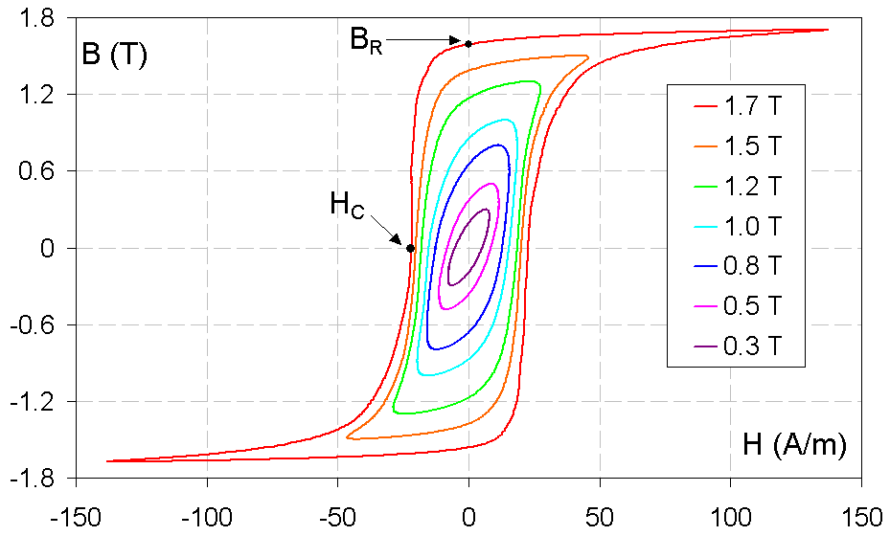

BR denotes magnetic remanence and HC is coercivity

The case of pure iron:

μr = 104 :

saturation induction **Bs = 1,7 T**

magnetic remanence **Br = 1,4 T**

coercivity field **HC = 85 A/m**

Magnetism at the mesoscopic scale

atomic scale 10-10 m. micro usual

optical scale 10-3 m to 10-4 m.macro

the mesoscopic scale is intermediate.

Experiments show that all magnetic materials of sufficient volume spontaneously divide into smaller regions called Weiss domains .

Within these areas, the magnetic polarization is unidirectional.

Sample configuration:



Overall, these areas are designed according with the minimum rate of energy for a given temperature condition. They come from the opposition between the exchange forces between atoms that generate magnetism and the Coulomb force. The demagnetized State is obtained when the average magnetic polarization is zero, i.e. when the atoms move in all directions

**1.5/AMPERE’s theorem : HOPKINSON’s law :**



with L the number of electrical circuits across the surface.

Using STOKES’s theorem, we can write



 = = **-N1i1 -N2i2**

**1.5.1/Application to linear, high permeability circuits :**

 The reluctance of linear materials is defined as:  application to intensity transformer



i1+N2i2= .Φ



If L/S makes  small ⇒ i1+N2i2 ≈ 0 ⇒

If Φ is also small because of the choice of v

Don’t forget that i2 exists only with variable v because of Faraday’s law

If v is a continuous value, dφ/dt is null, as is i2.

This the basic intensity transformer used in power electronics to measure variable currents

**1.5.2/Application to real ferromagnetic circuit air gap:**

** 1.5.3/Application to an iron-core inductance with N turns:**



**The current /voltage relationship is linearized.**

**1.5.4/Graph of electromagnetic**:

Case of the sine voltage source

 Case of the no-load current of the voltage transformer

**u φ B H** i



**i = L oh ogof (u )**

**1.6/Ferromagnetic losses:**

**1.6.1 Hysteresis losses**

Existence of these losses

Calculation of the energy consumed by an iron core inductance: 

The specific volumic differential energy is:

Thus the surface of the hysteresis loop represents losses in the so-called ferromagnetic material:



Steinmetz suggested the following experimental formula:

PH = Ch.F.Bα

CH depends on the material

F is the activation frequency in the range 50-60Hz

For steels, CH goes from 2 to α.

**1.6.2 Eddy current losses :**

Ferromagnetic materials (Fe, Ni) are also electrical conductors.

Thus variations in flow induce voltage and therefore currents in the mass of the circuits in a plane perpendicular to the direction of the field.



Principle of calculation of losses: 

**examples of sheets for an Fe Si:ϖ transformer**

|  |  |  |  |  |  |  |
| --- | --- | --- | --- | --- | --- | --- |
| **quality** | **thickness mm** | **Induction for the H field AT/m** | | | **Losses w/kg**  **ω** | |
|  |  | **2500** | **5000** | **10000** | **1T** | **1.5T** |
| **93** | **0.35** | **1.46** | **1.55** | **1.65** | **0.93** | **2.35** |
| **100** | **0.35** | **1.46** | **1.55** | **1.65** | **1** | **2.5** |
| **110** | **0.35** | **1.43** | **1.55** | **1.65** | **1.1** | **2.7** |
| **120** | **0.35** | **1.43** | **1.55** | **1.65** | **1.2** | **3** |

**2 /Applications to electrical machines :**

**2.1/ Operating point of a magnet**

Let us take a simple model.

Any magnetic circuit of a motor has 3 settings

-The length of the magnet permanent:

-The conductive parts of the magnetic field of l

-The required minimum air gap for the proper mechanical operation of thickness **e**. **SA** the section of the magnet and **SF** the section of the conductive part.

It is assumed that the section of the air gap is **SF**.



The circuit is given by Ampere’s theorem:



Be = μ0He ; BFer = μ0μrHF ; Ba = f(Ha) material hysteresis curve

thus



because H is tangent to the displacement  on the field lines.

Furthermore, H is considered to be constant along a field line thus

**HFlF + Hala + He2e = 0**

**2nd useful law**:

**conservation** of flow of the magnetic induction field.

hypothesis: the magnetic circuit is without leakage, so is constant regardless of the section concerned.

Thus :

Φa = Φe = ΦF



Moreover :



so BaSa = BFSF = BeSF ⇒ Be = Ba

This gives

BF.SF = Be.SF ⇔ BF = Be

⇔ HFμ0μr = Heμ0

so HF = 

The permeability of the plate in FeSi 3 % material is greater than 4.103.

HF is considered very small compared to He.

Likewise, HFlF in front of 2He.e in spite of the weakness of e in front of lF.

thus



This is the equation of a straight line in the plane Ba  Ha.

It crosses the characteristic of the material at its **operating point**.

The following figure shows the **operating point** in a magnet which is the intersection **I** between the characteristic of the material and the straight line of the magnetic circuit. One of those is called Δ.

We are going to evaluate different straight line that come from different hypothesises



Remark 1 :

The magnet has 2 operating areas (2 opposing quadrants).

Remark 2 :

Operation I, induction **BI** is less than **Br** which is even less than **Bs**, hence the interest of a squarer cycle.

Remark 3

The slope is defined by the 2 air gaps. If this is changed during disassembly, then straight line Δ becomes Δ'. On reassembly, there is no point I, but I ", obtained by a small cycle because the magnetic characteristic is irreversible.

The negative consequence is the obtaining of a magnetic field BI" below. BI

In this case Φ → Φ''< Φ

T = KΦIa → T'' = KΦ''Ia < T.

The performance of the motor has been reduced only by a maintenance operation.

Conclusions: Do not disassemble unless the magnet has a very strong HC.

Remark 4 :

∑NI = 0 can be false in rotation with high-intensity systems, since dissymmetry of ΔI can occur during graded rotation because of the armature winding. This amount can be significant in a strong overcurrent regime especially in a short circuit obtained with locked motor: Ia > Ian.

Hence the new formula is :



The sign ± means that ΔI increases magnetization (+) or decreases magnetization (-).

In the worst case, this is the minus sign and the return point becomes I"' with BI "' instead of BI

Conclusions: there is a limit that can’t be crossed without damage for the torque.

**2.2 Economic optimization of placement of the operating point**

Magnets are made with materials with strong coercive fields so as to avoid undergoing demagnetization, and with a strong residual field if possible to obtain the maximum flow. Since the 19th century, research has produced the following materials in order of appearance:

- martensitic steel

- Nickel Cobalt Aluminium alloy

- ferrite

- iron nickel

- rare earths such as samarium, cobalt,

- neodymium, iron, Boron.

- amorphous materials.

These more efficient materials in Br and HC are expensive (for example Samarium, Neodymium). It is therefore important to optimize the volume VA.

**For example :**

Ferrites Br = 0,4 T some €/kg

SmC0 Br = 0,8T

Neodymium iron boron Br= 1T 1,4T 40€/kg

From :

VA ≅ SaLa ; HaLa + 2eHe = 0 ; Be = μ0 He ; BaSa = BeSe

we can write: VA = SaLa  = He 

where 2eSe is the volume of the airgap.

At constant performance, the volume of the air gap is a constant, so reducing the volume of the magnet is obtained by searching for an operating point that maximizes the BaHa product.

**This is the Evershed criterion**.

The product **HaBa** , called specific energy, is plotted as a function of **Ba .**

It goes through a maximum..



**Building rule**: The point **I** is placed where the product **BaHa** is maximum, so the slope  is given by the construction .

If the slope is steep, the case of an AlNiCo material, with constant torque and therefore equal surfaces and constant gap, LA is high, hence long magnets.

If the slope is small, the case of ferrites in same geometric terms lA will be reduced and the magnet will be short. In this case, because of a lower remanent induction, maintaining the flow can only be achieved by increasing the sections Sa and SF like magnets tiles or plots.

|  |  |  |  |  |
| --- | --- | --- | --- | --- |
| **MATERIAU** | **Br** | **HC** |  | **Commentaires** |
| Aciers martensitiques | 1 T | 4 à 20 kA / m | 2 à 7 kℑ / m3 | 19th century construction |
| ALNICO | 0,7 T | 50 à 80 kA / m | 12 à 18 kℑ / m3 | appeared in the 30’ |
| FeSi  Forme anisotrope à cristallisation dirigée | 1, 4 T | 60 kA / m | 60 kℑ / m3 |  |
| Ferrites mélanges frittés d'oxyde de fer, de baryum et de strontium zinc ou manganèse | 0,2  à  0,4 T | 140  à  260 kA / m | 10  à  40 kℑ / m3 | cheaper and frequent use  θ until 100°C |
| SmCo5 | 0,95 T | 720 kA / m | 180 kℑ / m3 | expensive  θ until 250°C |
| Sm2Co17 | 1,07 T | 720 kA / m | 225 kℑ / m3 | expensive  θ until 350°C |
| NdFe14B | 1,2 T | 750 kA / m | 270 kℑ / m3 | θ until 100°C |
| Néodyme | 1,3 T | 950 kA / m | 320 kℑ / m3 | since 80’s  θ until 100°C |

From BRISSONNEAU & SEGUIER

**2.3 Designing a synchronous magnetic rotor machine:**

Simple model of magnetic material

Ba

BRR

Model Ba = BR + μ0. Ha

Ha



Two cases of rotors:

a : tile magnet b:earthed magnet

Sa≈ Se Sa≈ 4Se

 

With e/La= 0,1

Thus it is possible to obtain greater Be than Br , which is very useful with low induction materials.

For example ferrite

Br= 0,4T Be= 0,88T