**Polytech'Orléans**

**p o l y t e c h n i q u e**

***Institut***

***de l’université d’Orléans***

# Master AESM

Direct current engine

2013/2014

**1stsemester**

*Bruno Bonheur*

**1/ Design of the engine :**

Let us consider first of all the principle.

The pulsatance of the stator current is null, thus the coil is supplied with direct current. It is the field current which provides the magnetic induction B from north to south on the figure, which has one pair of magnetic poles (p=1). In addition, the pulsatance of current in the rotor is exactly the opposite of the angular velocity .



When the engine is a generator, the main principle is as follows:

 , the angular speed imposed from outside, creates electromotive forces (emf) in the strands identified by the angle (θ.) By applying Hopkinson’s law to the circuit based on the flux lines, we can write:



**ℜ** is the reluctance of the path followed by the magnetic flow emitted by the inductor pole. In practice the reluctance is limited to that of the gap because the permeability of the air gap is very low. The objective is to obtain a flow under a pole that is as high as possible, i.e. of the order of one tesla. At constant ampere-turn, this makes it possible to achieve the smallest gap possible.

There are 2 ways to obtain the necessary ampere-turn:

either many turns with a low ie current

or a few turns with a high current flow

which provides 2 types of inductor . 2 types of engine:

- series wound

- separately excited

**1.2/EMFcollected by a strand placed in the rotating rotor:**

**Principe of emf calculation in a strand :**

The B field is produced by the stator so it is constant.

**The rotor is m**o**ving** so the B field viewed in the rotor is moving too. If we consider that fact the emf collected by strand is given by the variation of Φ due to this movement.

So it appears the emf by induction :

**So it is necessary to calculate d**Φ on dS for a d displacement

Notice that

R is the radius

L is the length of the rotor

B is the induction vector directed to the rotating axis.

We will calculate the emf obtain with the induction l

Thus

And

→

and

**L**

**R**

dθ

This emf is collected on a strand throughout a rotation of 2 radians.



**e (t) depends on t as B on θ.**

Remarks :

First of all the voltage is alternating.

Secondly the shape is not a sine.

Third the voltage e(t) varies with time in the same way as B varies with the space parameter θ.

We’ll see later how to plan the design to obtain a sine for the emf (e) in alternating engines.

To produce a constant voltage we have to do two things:

* rectify the voltage
* fill the emf holes which then appear.

**1.3/ Commutator principle:**

**Rectify the voltage**

 neutral lines

The emf in each strand changes its sign at the crossing of the neutral line.

**Reduce the holes which appear because of the neutral line**

The emf is rectified by the association of collector and brush:

 one turn with 2 strands multiple turns

**Polar flow : Φp**



**Development of the calculation of the armature voltage**

Emf in a strand e = BLv

v is the linear speed of any point of the strand v = rΩ ⇒ e = 2πNBlr

Conversion betwween rd per s and run per s Ω =2πN ⇒ v =2πrN

This ce=reates the polar flow e =2φpN

2m notches with each 2 strands VA-VB=2em ⇒ VA-VB=4mφpN

n is the number of strands for the total winding 4m=n ⇒ VA-VB = **n N Φp**

simplification of the formula for the total EMF : E

N = Ω/2π ⇒ **E= K Φp Ω**

Where K is constant.

This very important formula indicates that E is linked to the angular speed.

It’s a reversible idea

**Imposing the voltage on the armature imposes the speed**

**Imposing the speed imposes the EMF, which is approximately the voltage**

**2 Use in generator:**

**2.1 generator without load : K = 0**

Wiring scheme equivalent electrical scheme



The armature voltage coincides with the emf E versus the field current and speed.



This characteristic inherits its pattern from the properties of ferromagnetic materials and from the air gap traversed by the magnetic field created by the inductor.

A typical use case is that of a speed sensor, called a tachometer generator.

**2.2/ Generator with load : K = 1**



The voltage upon the load is : UA = E- RA.IA

**3/ Operation of the motor**

**3.1 Role of the commutator**

All the strands under the same pole are traversed by a current of the same sign.**figure1 figure2**

**Important property**: when the rotor turns, the direction of the current of the conductors passing through the neutral axis is reversed



**Look at the error!**

**Magnetic State of the machine:**



The mechanical torque is given by the vectorial product of the total magnetic moment and the magnetic field of the inductor.



**Q1**: Then indicate the direction of the angular vector  in figure 2

**Q2** : The module of the moment is given by the following expression:



What is the value of θ? It is remarkable in the case of a direct current machine, called a vectorially well built machine.

**3.2 / Calculation of electromagnetic torque: TE=-Text**

**3.2.1** **Ideal engine: without any losses**

**3.2.2 Engine with a resistive armature:**





**3.2.3 Engine with a resistive armature and with mechanical losses:**

We need to introduce mechanical friction and ferromagnetic losses. These two quantities are transformed into heat, therefore into thermal power

Thus Pth +R.Ia2 +Pfer+Pemeca= 0 ⇒ Pth= -R.I2a - PFM

External mechanical interaction comprises 2 types of losses: losses due to mechanical friction, and ferromagnetic losses. Exchange with the outside is done in the new useful form of mechanical power PumecaIn practice, in modern engines PFM /Ω is of the order of 5% of the nominal value.

**4 Energy balance :**



**4.1 Current command**:

Power electronics resources materialize the notion of power source. Thus the following schematic is feasible. This gives the motorization of the remarkable properties

**.**

The torque is independent of the speed. The main applications are clamping and torque or pressure applications

**4.2** **Voltage command**:

**armature**

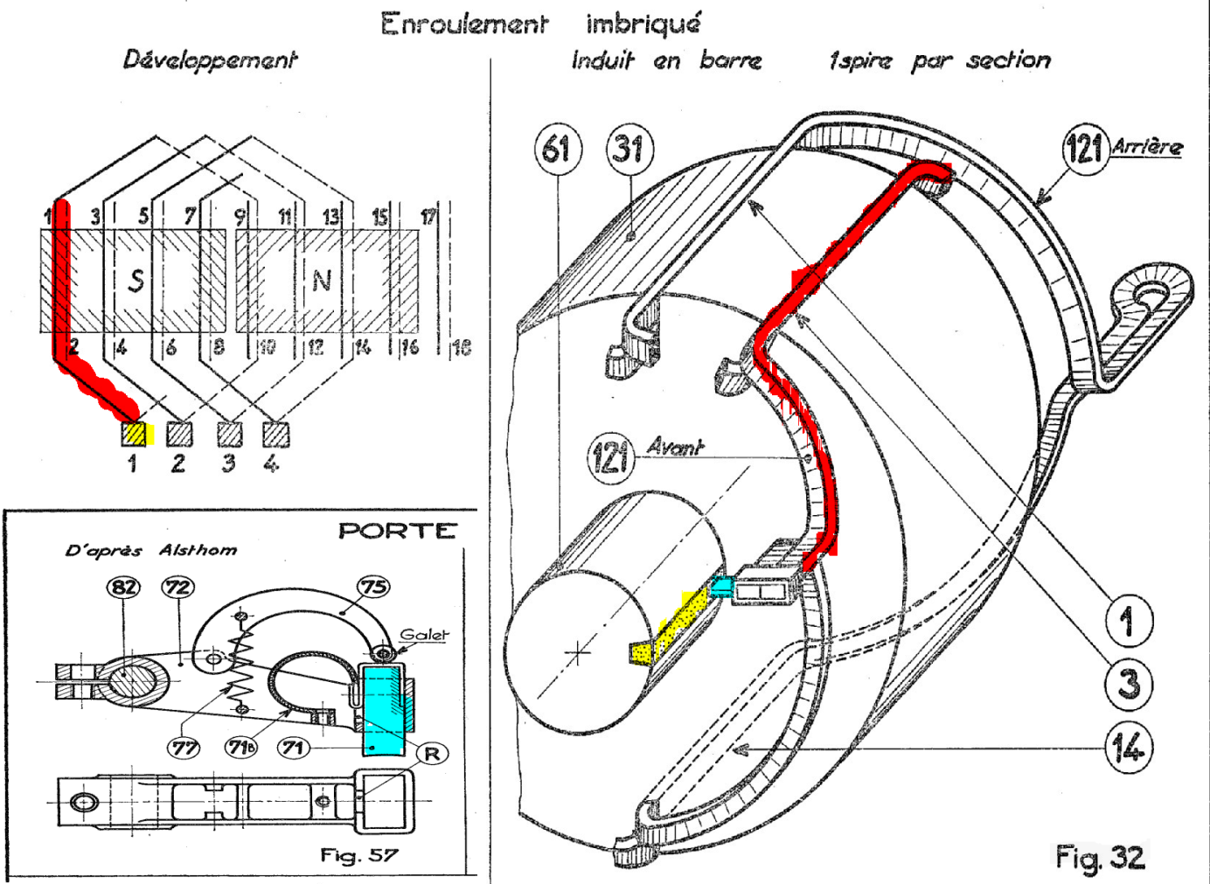

**Commutator**

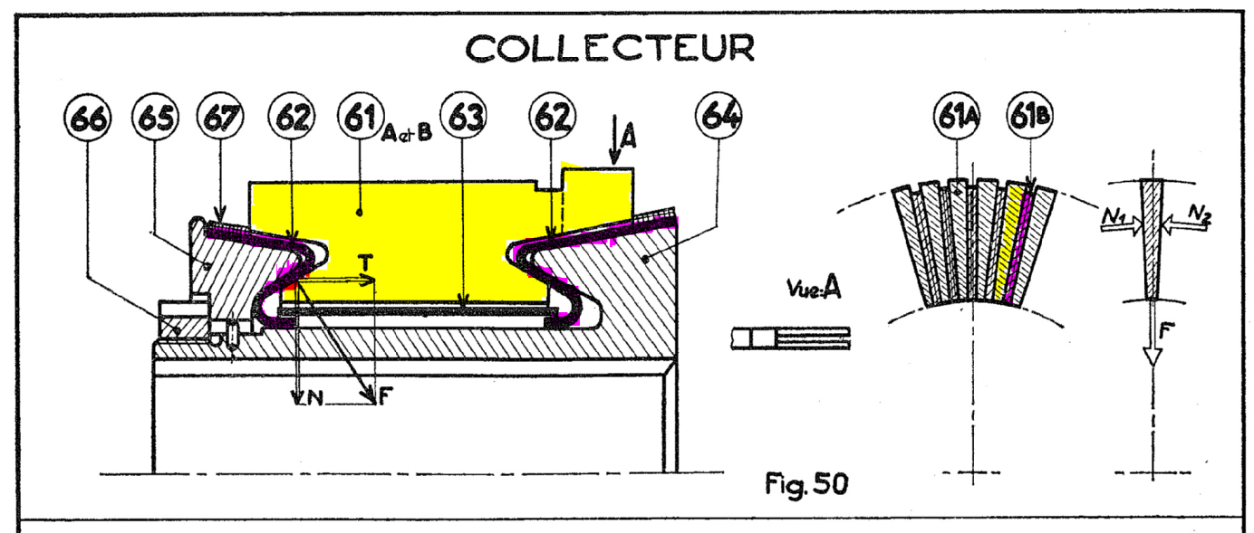



**4.3 Case of the dynamic direct current motor:**

See the next figure.

In modern motorization let us consider two important features:

1/ The motor is always used with electronic drives whose main property is to produce variable instantaneous voltages. Their frequencies are so high that the motor is sensitive only to the mean value of the armature voltage <ua>.

2/The inductor is made of magnets. Thus we modify the magnetic induction B which is constant, and the new formulaes for emf and torque are:

TE = KEia ; Tu = KTia

Wich a slight difference between the values of K because of the losses.

New calculation in the steady state:

 → <ua> = Ra <ia> + 0 + E

With TE = KEia ; Tu = KTia



so 



**Torque limits**

The weak point of electrical machines is the **temperature limit at which electrical insulators can be used** (insulation service type S1 class). The rotor temperature, denoted θR, must respect the inequation.



in local temperature θa. thus .

The major classes are given in the following Table :

|  |  |  |
| --- | --- | --- |
| class | Maximum reference heating  at 40°C ambient temperature | Temperature limit |
| A | 65°C | 105°C |
| E | 80°C | 120°C |
| B | 90°C | 130°C |
| F | 115°C | 155°C |
| H | 140°C | 180°C |

Source : EC standard EN 60034-1

**4.3.1 Thermal limit**

The main heat transfer process is solid conduction calculated with Fourier’s law:



where PD is the power to be dissipated

This formula indicates that the power to be dissipated is limited by a maximum which depends on the local temperature and the engine with K .

The main source of heat is joule losses given by the RMS value of the armature current:



RMS value  Electrical period T

These formulae lead to the inequation 

**In direct current**: Ia = ia = <ia>=TE/KE

⇒⇔

This calculation fixes the torque limit, which is thermal in origin, called nominal torque **Tn**, on the mechanical plane.

**In the variable current** **case of an association with drive:**

the RMS value of the current is different from its average value

The concept of current form factor f is adopted, such that



The torque requirement is given by the formula 

It is related to the current.

Thus 

With the current limit 

This modifies the previous formula slightly because of **f**

Example mono rectifier f = 1,2

Three phase rectifier f = 1,1

Chopper f = 1,05

It is clear that using only continuous current with an engine specified in nominal torque TN with a current form factor of 1.2 will reduce the torque performance by 20%.

The limit  is relative, it can be exceeded if the overflow does not last too long.

**4.3.2 Speed limit**

The maximum speed limit is mainly related to reasons of mechanical wear, so it is absolute.

**4.3.3 Commutation limit**

This limit is related to the commutation of the turns at the collector. This device reverses the current in the turn and in the blade to which it is connected, when it has left the brush.

Let us consider 3 commutator blades.



During the time from the left figure to the right the current reverses.

So voltage Surge occurs.



it is the time to leave the blade 

The surge must be less than the air breakdown voltage denoted , otherwise an arc corresponding to the ionization of air occurs, which will degrade the collector.

Thus 



This equation introduces a graphical limitation: this limitation is expressed by the following hyperbole.



This limit is obviously absolute because arcs produce local fusing of the copper of the collector that modifies the surface state, creating cracks.

**4.3.4 Magnetic limit**

We have seen in AESM 3, Section 2.1: remark 4, that the current cannot exceed certain values without risking demagnetization of the magnets.

This is the reason for the magnetic limit.

A single exceeded value will damage the magnets.